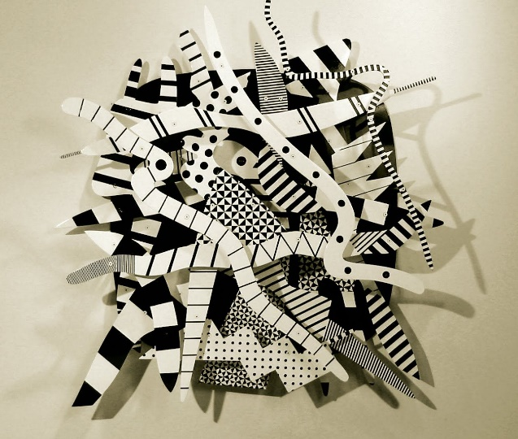
Monochrome paper sculpture based on the abstract work of American artist Charles McGee

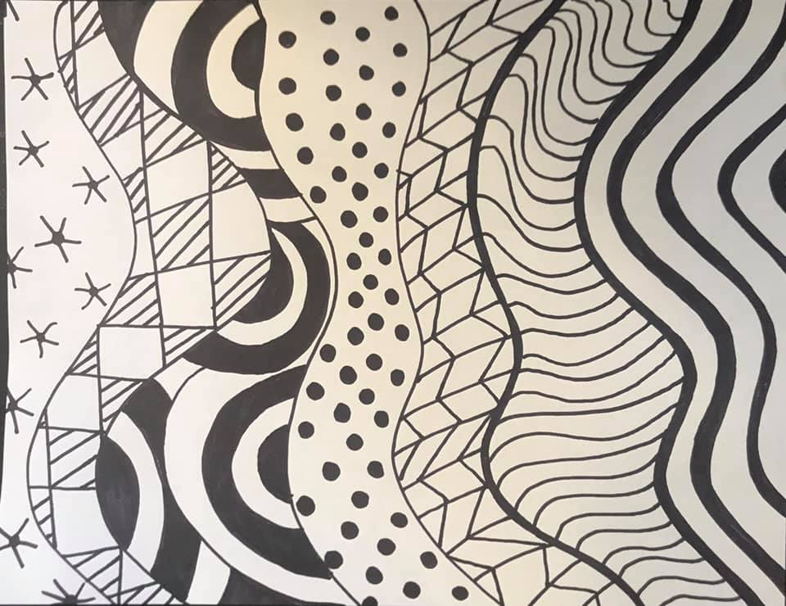
1) First create wavy lines down the width of a blank page. Create a different pattern in each section.

2) Cut out each of the sections, along the wavy line.

3) Fold up a small lip on each end of every strip. Stick these down on a piece of card board, overlapping and twisting them into an interesting composition.
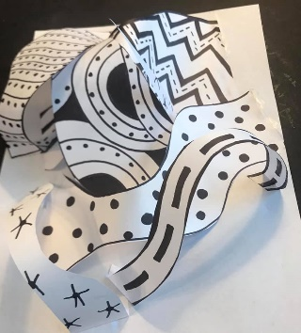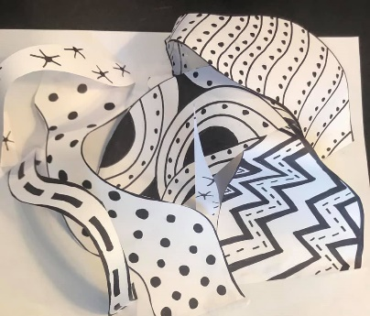

Explosion Book
Once you have followed the instructions and made your book then you can cut out the mini-squares and cut them into triangles, decorate them and stick them into your book.
How To Make An Explosion Book - YouTube
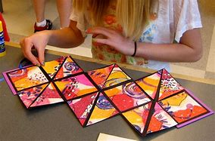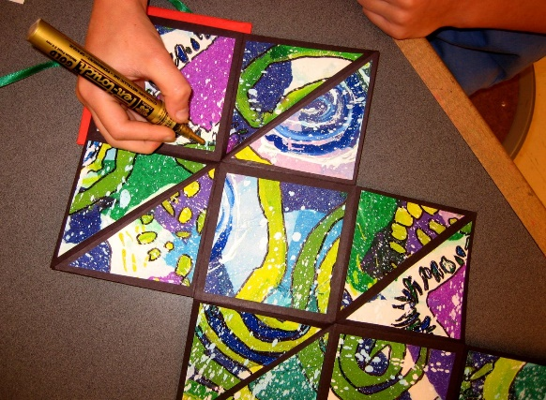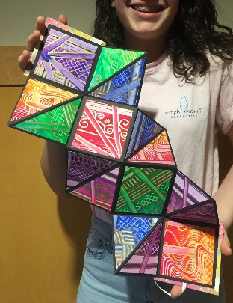

Warm and Cold Cityscapes
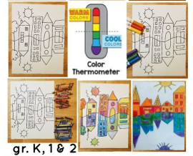
Have pictures of different buildings to use for ideas. Colour in felt tip, pencil crayon or even paint.
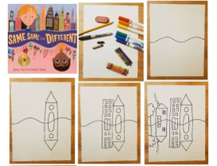

A perspective Aquarium tunnel
Aquarium Perspective Lesson Art for kids - Leah Newton Art – full step by step details (not video)
One-Point Perspective Aquarium Tunnel - Step by Step - YouTube
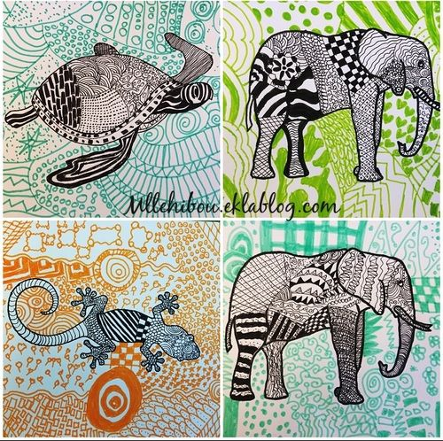
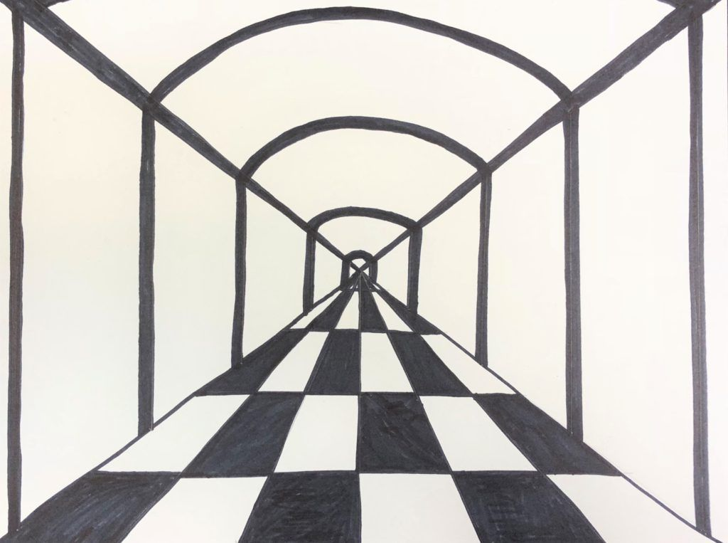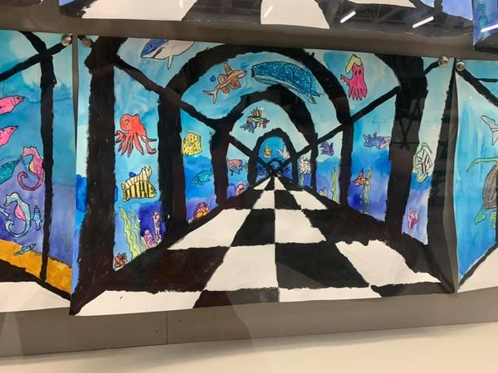

Zendoodle animals
Create a coloured, patterned background. Once you have also added a black pattern to the animal, cut it out and stick it on the background.
(Or you could do it the other way round!)

(Templates on the last few pages.)

Be a Cardboard Picasso
HANDMAKERY » Masks In the Making
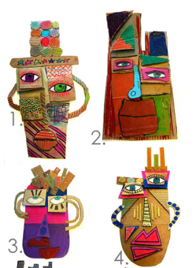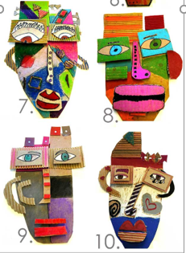

Rainbow trees
Paint in the trunk and branches reaching out to the edge of the page. Add some smaller branches in to break up each section. Once dry add a different colour in each section and paint the background sky.
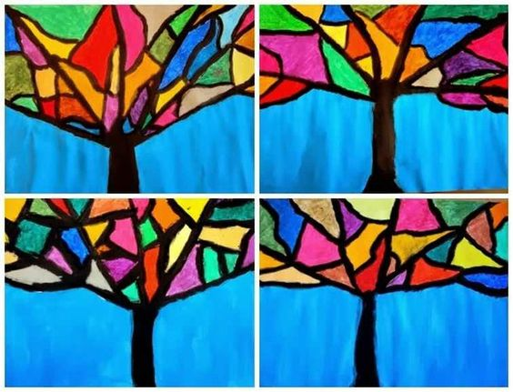

Foil sculpture
Look at the work of Giacometti. Create sketches of different body poses and create some using foil.
Giacometti art lesson :: sculpture project for kids - NurtureStore
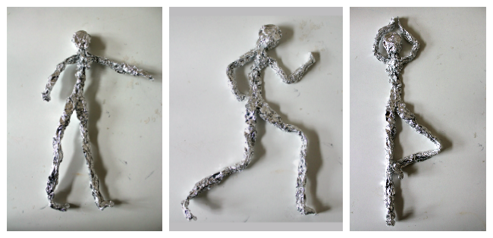

Magazine sketching
Find a picture in a magazine (or one you print from the internet). Stick it on a piece of paper and ‘complete’ the picture around it. It can be realistic or totally mad!
