- This Gruffalo spotter guide asks you to look out for signs of Spring approaching
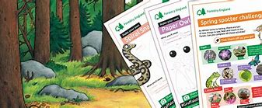
Gruffalo Spotters_Activity Spotter Sheet A4 _final.pdf (forestryengland.uk)

- Do you like to play Top Trumps? This is a way to get to know your trees – Tree Trumps! It looks great and we will be playing it at home.
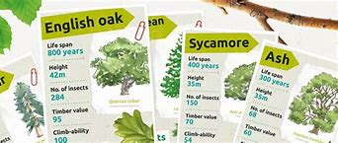
Forestry England - Tree Trumps (A4) print at home.pdf

- This pack gives lots of activities to have a go at!
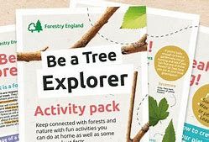
Tree Explorer Activity Pack-2020.pdf (forestryengland.uk)
- This pack is great for facts and has a word search for you to have a go at too.
Fantastic forest activity sheet.pdf (forestryengland.uk)
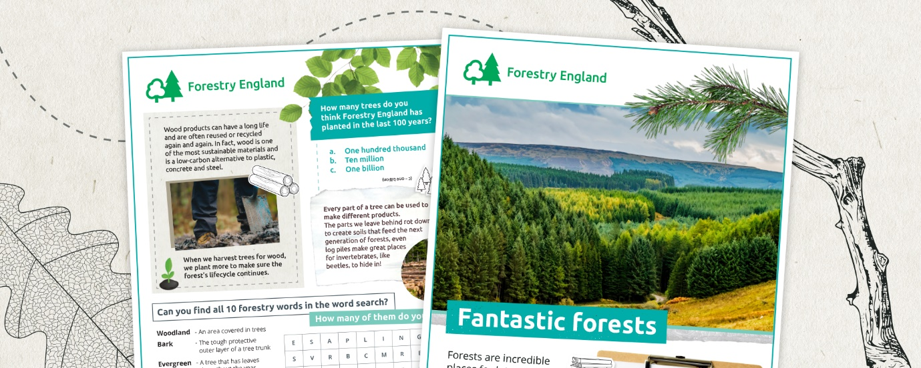

- This pack is all about night time animals with quizzes and word searches
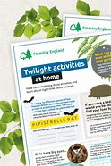
Twilight activity sheet.pdf (forestryengland.uk)

