How to make a toilet paper roll bird feeder

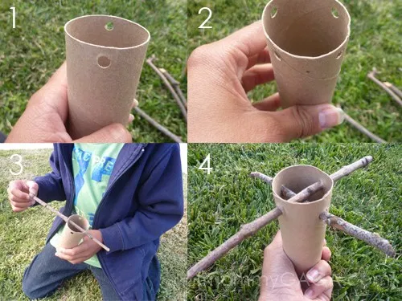
You will need:
- toilet paper rolls
- 2 sticks
- bird seed/ nuts/seeds
- peanut butter
- string or ribbon
- something to make holes

- Make 2 holes at one end of the toilet roll to thread the string through to be able to hang it up.
- Turn the toilet roll the other way up and make 4 holes to thread the sticks through – this is for the birds to sit on. 2 of the holes will need to be slightly higher to fit both sticks through.
- Cut the string and thread it through the top 2 holes to hang up your bird feeder.
- Spread peanut butter over the cardboard tube, then stick your seeds, nuts or bird seed to the peanut butter.
- Carefully push a stick through the end with 4 holes.
- Push the second stick through so that they cross over.
- Find a good place to hang your bird feeder, out of reach of cats, and watch to see who comes for dinner!!
