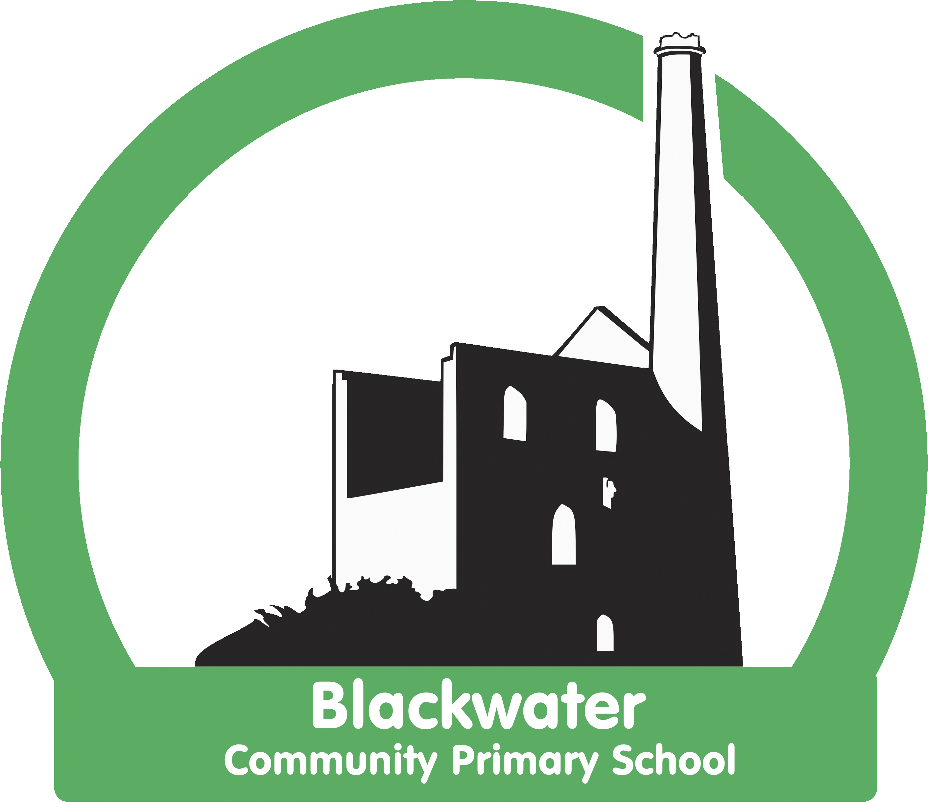

Blackwater Art Strategy
2021 - 2022

Statement of Intent
At Blackwater, art is an integral part of school life. We believe that art is at the centre of developing innovation, creativity, critical thinking as well as being a vehicle for self discovery and expression. After all humans have been drawing for over thirty thousand years! We endeavour to deliver a high quality art and design curriculum encouraging and inspiring our children create, innovate and embark on a journey of discovery of themselves and the wider world. Our art and design curriculum engages children in a progressive programme of ‘learning to do’ and ‘learning about.’

Learning to do:
Generating ideas: The skills in designing and generating ideas
Creating and making: The skills of making in art, craft and design.
Evaluating: The skills of judgement and evaluation
Learning about:
Knowledge: knowledge about the technical process and work of artists and artistic movements
Children are taught through a sequence of lessons to develop their skills, experiment with ideas and materials, think critically about others’ work as well as using what they have learned to create a ‘final piece’ to be shared and celebrated.
Statement of Implementation
Art is taught through a two year rolling programme with a focus on:
Creativity
Materials
Natural Art/Place
Significant artist or artistic movements
Children are taught and practise to master a range of art techniques: line, colour, pattern, texture, shape, form and space.

Our process looks like this:
Analysis  Photograph of chosen piece with children’s comments. | Technique  Practise of focus techniques. | Deconstruction  Evidence of exploration and practice of techniques included in ‘component parts’ of final piece. | Final Piece  Bringing together artist’s influence and new techniques

In KS1
The children:

- Use a range of materials creatively to design and make products.
- Use drawing, painting and sculpture to develop and share their ideas, experiences and imagination.
- Develop a wide range of art and design techniques in using colour, pattern, texture, line, shape, form and space.
- Learn about the work of a range of artists, craft makers and designers, describing the differences and similarities between different practices and disciplines, and making links to their own work.

In KS2
The children:
- Create sketchbooks to record their observations and use them to review and revisit ideas.
- Improve their mastery of art and design techniques, including drawing, painting and sculpture with a range of materials (for example, pencil, charcoal, paint, clay)
- Learn about great artists, architects and designers in history.

Techniques are taught through a two year rolling programme to ensure progression as well as enabling children to practise and eventually master these techniques. Progression of key skills is detailed in the skills progression programme of study for each class. Techniques are taught through a spiral curriculum where techniques are revisited through a variety of media and contexts.
Each term focuses on a particular artist, piece of work and set of techniques. The art or artist is linked to the cross curricular topic each term.
Each term the children will:
Practise and work towards mastering art techniques.
Explore the life and work of a particular artist.
Analyse a piece of art deconstructing it into component parts.
Apply their art techniques to recreate their ‘final piece’.
Evaluate their creations and progression of skills.
Art in EYFS is a powerful vehicle for all learning. Children’s creativity is stimulated, nurtured and developed through high quality continuous provision and small group teaching. The children will engage spontaneously with art materials, exploring techniques and progressing skills through play and exploration as well as working on specific techniques through small group work. Their learning journey is documented through Tapestry and an art floor book.
The learning journey through KS1 to KS2 is documented in children’s art portfolio and includes exploration and practise of art techniques, deconstruction and creation of final piece. This portfolio will travel with the children from Year 1 to Year 6 culminating in a wonderful celebration of the development of the children’s technique and creativity.
Children have the opportunity to use art to enrich their cross curricular learning. In March the children are able to explore the link between maths and art in an annual maths/art day.
At Blackwater we aim to enrich the children’s creative experiences working with local artists to create art installations in the outside space as well as the school environment. The focus this year is ‘The Lost Words’ and local graphic designer is working with the children to create four canvases for the school dinner hall. Artists are also being employed to work collaboratively on playground art installations and projects to enrich our outdoor space.
Assessment
Children are assessed in terms of their skills and knowledge. Progress criteria are detailed in Appendix 1 and focus on four aspects :
Learning to do:
Generating ideas: The skills in designing and generating ideas
Creating and making: The skills of making in art, craft and design.
Evaluating: The skills of judgement and evaluation
Learning about:
Knowledge: knowledge about the technical process and work of artists and artistic movements

`
Statement of Impact

Art is central to the life of the school which is evident in the art installations inside our building and in the outside space. Art enriches our children’s experience of learning across the curriculum and our school environment as well as engendering creativity.

Art is monitored by the subject leader throughout all year groups using a variety of strategies such as, portfolio evidence, lesson observations, learning walks and pupil voice. The spiral art curriculum, interleaving learning of art and engaging the children in a range of materials, artists and artistic movements and creative endeavours ensures that the children have a broad and deeper understanding of art techniques, creativity and how these have been applied by a variety of artists. This is evidenced in the porfolios and in discussion with children.

The subject leader feeds back findings to staff and the effectiveness of art delivery is discussed and monitored.

