**Design Technology and Art**

Art will be led by Mrs Mannion again this term. Children will look at art through Nature and animals.

**Topic**

This term or topic revolves around our own homes and the homes of others around the world. This includes a comparison between ancient Greek homes and our modern day homes. We will also look at the habitats and homes of animals around the world.

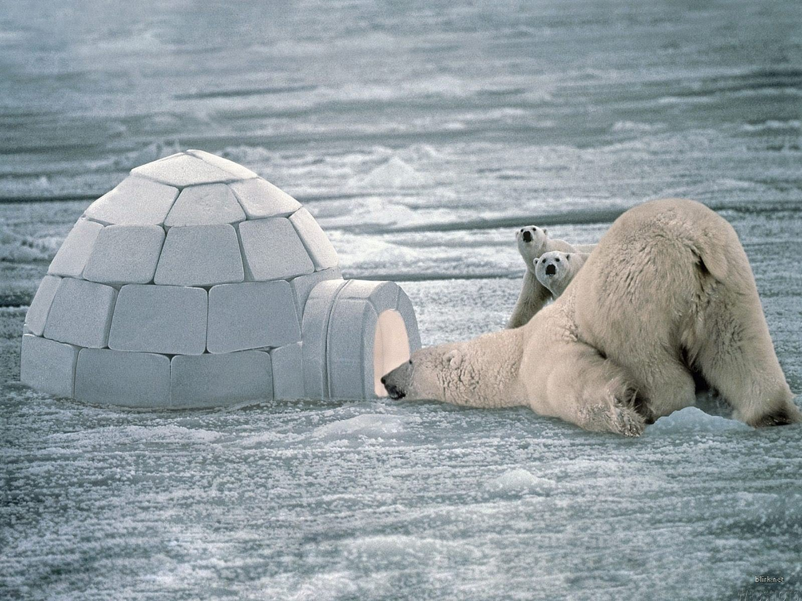

**English**

Children will have daily vocabulary, reading, spelling, handwriting and grammar work. We will be looking at fact files and information writing, as well as quest stories and narratives. Narrative writing will focus on character and setting, using ICT to inspire an immersive approach. There will be some time spent on writing poems to our leavers as well.

**PSHE**

This half term we will continue to look at changes and moving on. We will also have sessions based around our Thrive ethos.

**Science**

This half term we are continuing our look at living things, including Sex and Relationships education and the effect drugs and alcohol has on the body. Please see the letter coming home about these sessions before we begin them. We will be exploring homes, habitats, evolution and inheritance.

**“Home, Sweet Home!”**



**Languages**

We will be continuing our look at Ancient Greek! 

**Computing**

We are going to be looking at word processing skills and skills for life in everyday settings. We will focus on shortcuts, keyboard skills and basic formatting. We will also be creating presentations, slide shows and movies and using 3D landscapes to inspire writing.



**Physical Education**

We are looking at the Health and Fitness aspect of PE this term, concentrating on balance and co-ordination.

**Maths**

Children will explore reasoning, problem solving and mental arithmetic daily. We will continue to work on developing accurate and speedy recall of times tables and division facts, and will now include word problems with this. Our main focus this term will be; telling the time; symmetry and translations; data handling and presentation and problem solving.

**RE**

We are looking at the spiritual and personal aspect of worship this half term. We will spend time on reflection, mindfulness and how we accept and respect many beliefs even if they are not our own.