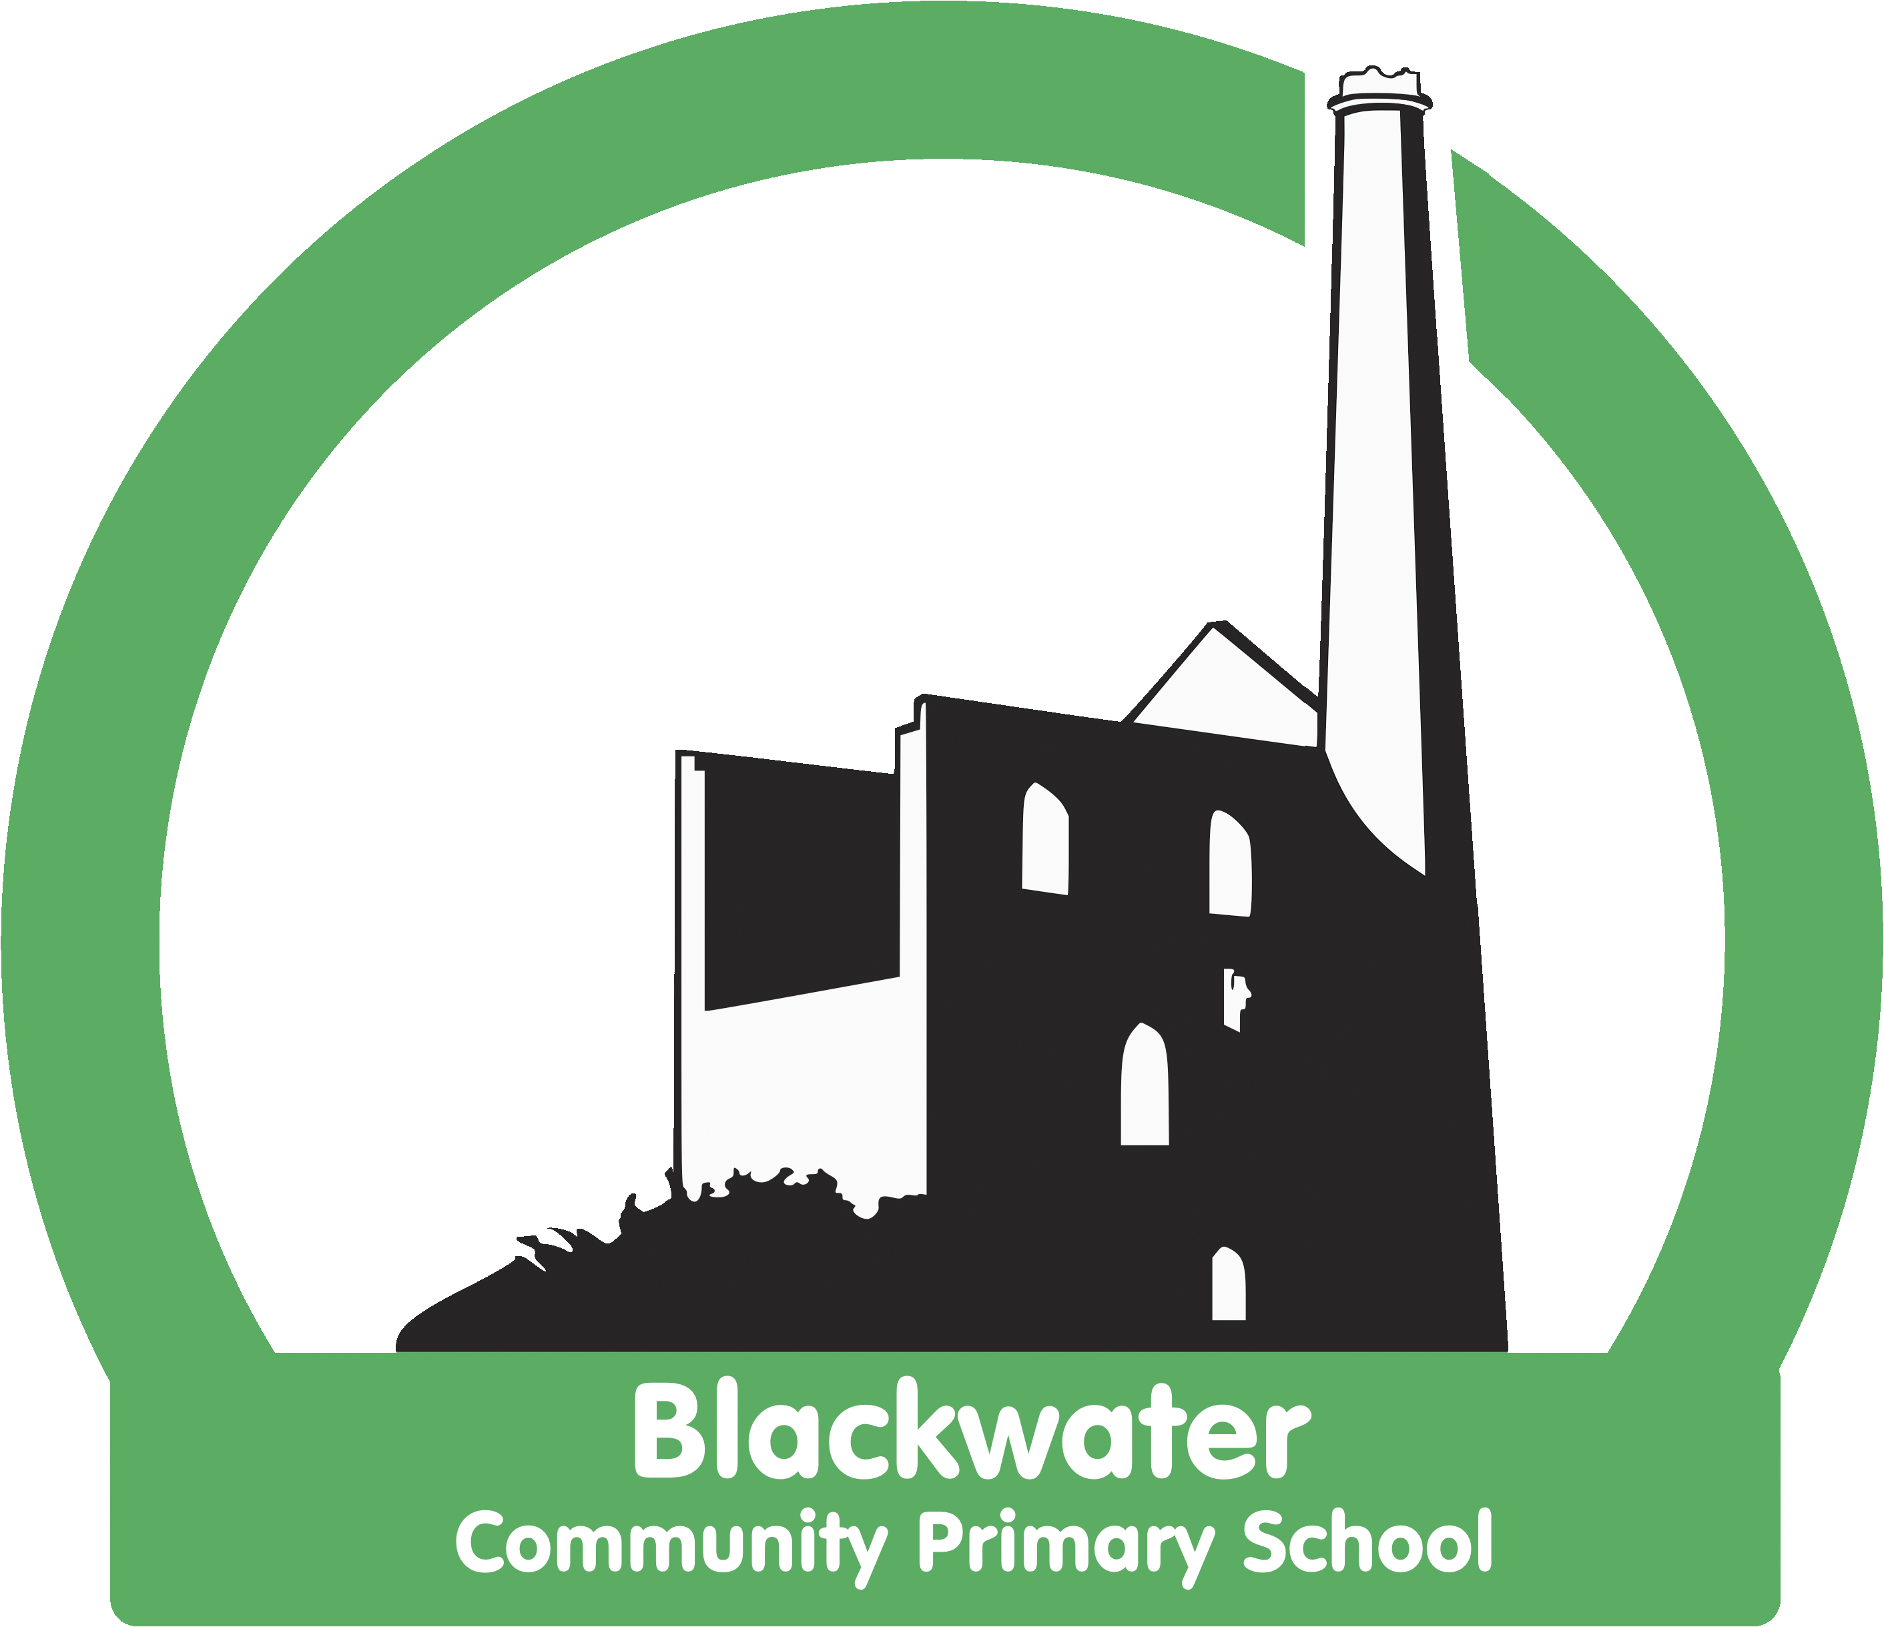

Blackwater Community Primary School

COVID 19 Outbreak Plan
September 2021 - 2022

Introduction
This plan is based on the contingency framework for managing local outbreaks of COVID-19, provided by the Department for Education (DfE).
We will only implement some, or all, of the measures in this plan in response to recommendations provided by our local authority (LA), director of public health (DsPH), Public Health England (PHE) health protection team or the national government.
It may be necessary to implement these measures in the following circumstances, for example:
- To help manage a COVID-19 outbreak within the school
- To help managed a suspected COVID-19 outbreak within school (5 positive cases amognest pupils or staff who are likely to have mixed closely within a 10 day period and/or 10% of pupils or staff who are likely to have mixed closely test positive within a 10-day period.
- If COVID-19 infection rates in the community are extremely high, and other measures have failed to reduce transmission
- As part of a package of measures responding to a ‘variant of concern’ (VoC)
Shielding
We will adhere to national guidance on the reintroduction of shielding, which would apply to those on the shielded patient list (SPL).
We will speak to individuals required to shield about additional protective measures in school or arrangements for home working or learning.
Other Measures
If recommended, we will limit:
- Residential educational visits
- Open days
- Transition or taster days
- Parents coming into school
- Requesting that parents wear masks when dropping off and collection children especially when on the school premises
- Whole school assemblies
- Staggered starts
- Mixing of children
- Live performances

Attendance restrictions
Attendance restrictions will only be recommended as a last resort. If recommended, we will implement the measures in this section.

Eligibility to remain in school
In the first instance, we will stay open for:
- Vulnerable pupils
- Children of critical workers
- Reception, Year 1 and Year 2 children
If further restrictions are recommended, we will stay open for:
- Vulnerable pupils
- Children of critical workers
Education and support for pupils at home
All other pupils will be required to stay at home and will receive remote education.
We will aim to deliver remote education that meets the same quality and quantity of education that pupils would receive in school, as outlined in our Remote Learning Plan on our website. The school will continue to provide food parcels provided by Autograph for pupils eligible for benefits-related free school meals while they are not attending school because of COVID-19 isolation guidelines. These food parcels will be delivered directly to eligible families within 24-48 hours of closure.
Wraparound Care
We will limit access to before and after-school activities and wraparound care during term time and to those that need it most.
We will communicate who will be eligible to attend once the restrictions are confirmed.
Safeguarding
We will review our child protection policy to make sure it reflects the local restrictions and remains effective.
We will aim to have a trained DSL or deputy DSL on site wherever possible. If this is not possible they will be contactable by telephone and or email for advice.
DSL support can also be sought through the MAT as the Safeguarding Lead for TPAT.
When vulnerable pupils are absent, we will:
- Speak to parents/carers and, where applicable, social workers and the local authority, to work out the reason for absence
- Encourage attendance
- Make sure vulnerable pupils can access appropriate education and support while at home
- Maintain contact, and check regularly that the pupil is able to access remote education provision.
Signed

This policy was reviewed and received the agreement of the chair of Governors at the meeting in August 2021 and will be reviewed every year
Signed Chair of Governors: Date August 21
Signed Head Teacher: Date August 21

