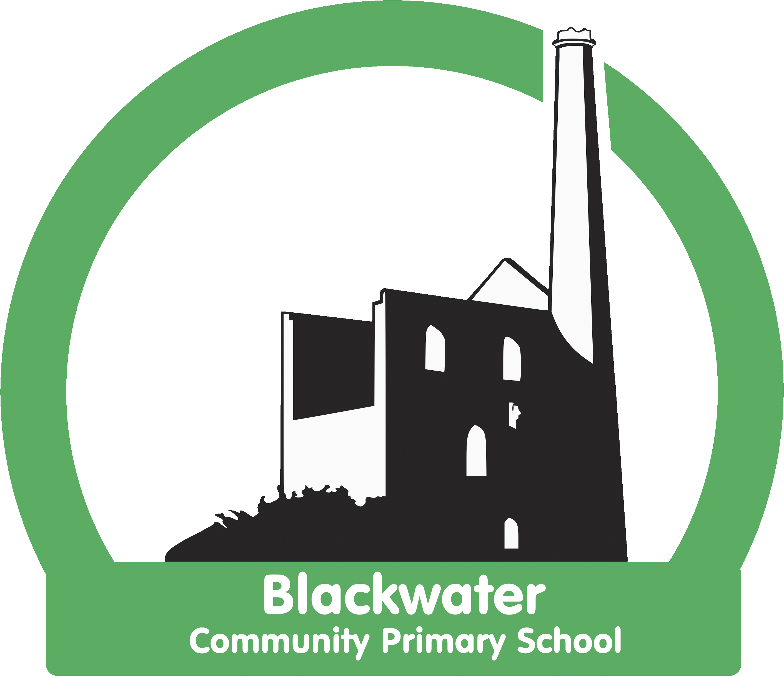

Blackwater Science Strategy
2021- 22

Blackwater Science Principles
These principles were made with staff, governors and pupils of the school:

- We teach Science as it is linked to our topics through the Cornerstones Curriculum.
- Science builds on and nurtures the awe and wonder of childhood curiosity.
- It creates and develops a desire to be a responsible Global Citizen aware of issues globally and in particular the environmental challenges faced by future generations.
- It creates links across the curriculum and to the “real world”.
- Utilises local industries, planning for the needs of our children as the workforce and minds of the future.
- Lessons are often immersive and practical.
- We use the outdoors whenever possible.
- Lessons do not always include written work, but children use the language of scientific enquiry and do a written piece half termly.
- We use floor books/project books to record learning.
- There are wider opportunities to engage with Science (STEM, Gardening and I wonder Clubs)

Statement of Intent

At Blackwater Primary School, we recognise the importance of Science in every aspect of daily life. As one of the core subjects taught in Primary Schools, we give the teaching and learning of Science the prominence it requires. Research has shown that Science success is closely related to reading and maths ability. Therefore, we link Science with other curriculum areas to ensure excellent attainment – for example vocabulary and reading sessions linked to Science units regularly.

The Scientific area of learning is concerned with increasing pupils’ knowledge and understanding of our world, and with developing skills associated with Science as a process of enquiry. It will develop the natural curiosity of the child, encourage respect for living organisms and the physical environment and provide opportunities for critical evaluation of evidence.

At Blackwater Primary School, in conjunction with the aims of the National Curriculum, our Science teaching offers opportunities for children to:
- develop understanding of the nature, processes and methods of Science through different types of science enquiries that help them to answer scientific questions about the world around them;
- be equipped with the scientific knowledge required to understand the uses and implications of Science, today and for the future.
- explore perspectives in science linked to our topic based curriculum.
- develop the essential scientific enquiry skills to deepen their scientific knowledge.
- use a range of methods to communicate their scientific information and present it in a systematic, scientific manner, including I.C.T, diagrams, graphs and charts.
- develop a respect for the materials and equipment they handle with regard to their own, and other children’s safety.
- develop an enthusiasm and enjoyment of scientific learning and discovery.

The National Curriculum will provide a structure and skill development for the science curriculum being taught throughout the school, which is now linked, where possible to the theme topics to provide a creative scheme of work, which reflects a balanced programme of study over a two year rolling programme.

At Blackwater Primary School:
Children have weekly lessons in Science throughout Key Stage 1 and 2, using the Cornerstones Curriculum, PZAZ resources, Explorify resources, our two year rolling programme and Plan Assessment Knowledge Matrices. In Early years, science is taught through the children learning about the world around them in their Continuous Provision and through focused activities. Additional opportunities are provided in Science, such as STEM clubs, field trips and outdoor learning.

We endeavour to ensure that the Science curriculum we provide will give children the confidence and motivation to continue to further develop their skills into the next stage of their education and life experiences.

Statement of Implementation
Teachers create a positive attitude to science learning within their classrooms and reinforce an expectation that all children are capable of achieving high standards in science. Our whole school approach to the teaching and learning of science involves the following;

Planning
- Science will be taught in planned and arranged topic blocks by the class teacher. This is a strategy to enable the achievement of a greater depth of knowledge.
- We encourage the use of talk and questioning in all year groups using the Explorify platform.
- Through our planning, we involve problem solving opportunities that allow children to find out for themselves. Children are encouraged to ask their own questions and be given opportunities to use their scientific skills and research to discover the answers. This curiosity is celebrated within the classroom. Planning involves teachers creating engaging lessons, often involving high-quality resources to aid understanding of conceptual knowledge. Teachers use precise questioning in class to test conceptual knowledge and skills, and assess children regularly to identify those children with gaps in learning, so that all children get the support they need to achieve to their best ability.

Assessment
- Children are assessed termly by teachers using the TAPS resources and currently 0-9 Jason Hurr data collection method as other subjects through the school. This data collection is on a termly basis and guides our Science development for the future.
- We build upon the learning and skill development of the previous years – including vocabulary. As the children’s knowledge and understanding increases, and they become more proficient in selecting, using scientific equipment, collating and interpreting results, they become increasingly confident in their growing ability to come to conclusions based on real evidence.
- We use assessment quizzes at the start and end of each unit and assess how well they understand and use vocabulary.
- We mark the children’s Floor and Topic books using whole class feedback in which all children are given feedback on their previous lesson, ensuring that high expectations are shown of amazing science learning.

Teaching and Learning
- Working Scientifically skills are embedded into lessons to ensure these skills are being developed throughout the children’s school career.
- New vocabulary and challenging concepts are introduced through direct teaching. This is developed through the years, in-keeping with the topics.
- Teachers demonstrate how to use scientific equipment, and the various Working Scientifically skills in order to embed scientific understanding.
- Teachers find opportunities to develop children’s understanding of their surroundings by accessing outdoor learning and workshops with experts.

What this looks like

- 2 Hours of science focused teaching/learning a week.
- Floor books record learning each week
- Floor books to have a title page with unit vocabulary for each topic.
- Clear objectives to be set out in these, children’s work to be evidenced with post it’s and photographs of practical engagement.
- Display in each class with posters – posters are the same through classes to aid children identifying enquiry type as they progress through the school.
- Unit vocabulary to be on Science display.
- Half termly science writing in Topic books
- Pre teaching vocabulary particularly to children with SEN and adapting resources.

Statement of Impact

The successful approach at Blackwater Primary results in a fun, engaging, high-quality science education, that provides children with the foundations for understanding the world. Our engagement with the local environment ensures that children learn through varied and first hand experiences of the world around them. So much of science lends itself to outdoor learning and so we provide children with opportunities to experience this. Through various workshops, trips and interactions with experts and local charities, children have the understanding that science has changed our lives and that it is vital to the world’s future prosperity. Children learn the possibilities for careers in science as a result of our community links and connection with national agencies such as the STEM association. Pupil voice is used to further develop the Science curriculum, through questioning of pupil’s views and attitudes to Science to support the children’s enjoyment of science and to motivate learners.

