**Design Technology and Art**

Learning will be centred on our local area, looking at the creativity and beauty of old maps. We will be making self-portraits and table settings expressing our individuality, likes and dislikes.

The class will be looking at food and nutrition in Design and Technology. We will share likes and dislikes, analyse packaging and devise adverts. Children will also decide what food type they would like to adapt to their own tastes, and bake at school – delicious!

**Topic**

Our learning this half term will revolve around our topic of “This is Me”. We will explore our own personalities, likes, dislikes. And what makes each of us unique and important.

Looking at where we live, children will explore the history of Blackwater and Cornwall. This will include how land has been used in the past, and how we use land now. We will also be exploring the river Fal.

**English**

Children will have daily vocabulary, reading, spelling, handwriting and grammar work. We will begin by creating “Blackout Poems” based on our own interests, feelings and personality. Writing this half term will include biography, based upon a role model or hero children choose themselves. We will be reading “The Nowhere Emporium” by Ross Mackenzie.

**This is Me**

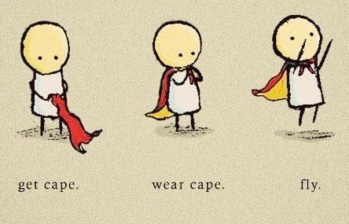

**Languages**

This half term we are looking forward to starting to learn some Spanish! We will begin with greetings and move on to our likes, dislikes and families. Children will focus on speaking and listening this half term.

**Science**

We will examine what thinking scientifically means for each of us, and what we do in our everyday lives that really is rather spectacular. Children will lead practical experiments, based on their interests – think slime, custard powder experiments, effervescent vitamins and standing on eggs.

**Physical Education**

We are fortunate enough to be able to have The Cornish Pirates schools outreach team coming in to work with children on a weekly basis developing their Tag Rugby skills.

**Mathematics**

This half term we will be focusing on number and the number system with an emphasis on place value. Then we will begin work on calculating with the four operations, including checking answers, rounding and estimating. Children will explore reasoning, problem solving and mental arithmetic daily.

**Computing**

Children will consider digital wellbeing, rights and responsibilities, safety and where to go when they need help in their digital lives. They will create online adverts, vlogs and documents using a range of programmes and tools.

We will take a look at legislation and current research into technology, debating topics like privacy, age ratings on games and mobile phones.

**PSHE**

Initially we will begin by looking at expectations and how we treat each other. We will create a class contract, and then go on to explore managing feelings, behaviour and friendships. This half term we will use a range of learning experiences to develop teamwork, confidence and communication.

**RE**

We will be looking at Cornwall as a spiritual place and Christianity in Cornwall.