16. Trustees information and duties

Link and address below.
Please contact Chris Wilson, via
head@blackwater.cornwall.sch.uk
if link is broken
https://www.tpacademytrust.org/governance/
Bottom of Form

Governance
Truro and Penwith Academy Trust is a charitable company limited by guarantee (Company number 08880841). Governance of the Trust falls within the responsibility of Members and the Board of Trustees.
The Members:
- are signatories to the articles of association (which sets out the trusts’ charitable objects and governance structure) and have the power to amend the articles of association
- have power to appoint a number of the Trustees and to remove any or all serving Trustees
- may issue direction to the Trustees to take a specific action
- have power, ultimately, to wind up the academy trust.
The Trustees are both charity trustees and company directors and have the legal responsibility for conducting the business of the trust. They may choose to delegate certain powers to committees or to the local governing boards of academies in accordance with a Scheme of Delegated Authority (SoDA).
In particular, Trustees have responsibility to:
- ensure clarity of vision, ethos and strategic direction
- hold executive leaders to account for the educational performance of the organisation and its pupils, and the performance management of staff
- oversee the financial performance of the organisation and make sure its money is well spent.

Members
The current Members are:
Mr P Callen MBBS FRCS FRCOG
Mrs C Mewton CertEd BEd(Hons)
Dr Barbara Vann MA PhD DL
Mr D Walrond MA MBA PGCE
Mrs Ellen Winser MBE MA(Cantab) DL

Trustees

Jennifer Blunden
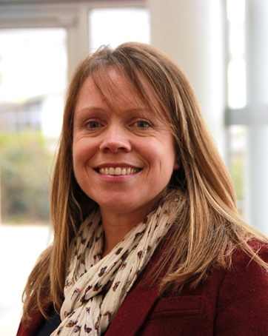
Chief Executive Officer and Trustee/Director
Appointed September 2015
Dr Jennifer Blunden is the Chief Executive Officer for the Trust, taking up post in September 2015. Previously Director of Cornwall Teaching School, Jennifer has experience of leading successful partnerships with schools across educational phase from early years to higher education. Jennifer is currently a co-opted member of the national Teaching Schools Council.

Bob Crossland
Trustee/Director
Member of Performance & Remuneration Committee
Appointed February 2014
Bob was a town planner before changing career and training in social work. He has worked in the probation service, in prison and the community, both locally in Cornwall and in Bristol. Prior to retirement in 2013 he was the manager of the Drug and Alcohol Action Team for Cornwall and the Isles of Scilly, commissioning and co-ordinating drug and alcohol services. He is currently a Governor of Truro and Penwith College, a Director of White Gold Cornwall, a community interest company that works with vulnerable and disadvantaged young people.

Sue Dickinson
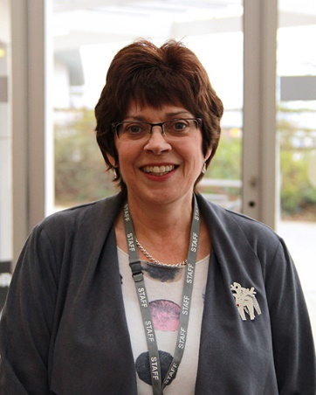
Trustee/Director
Appointed February 2014
Sue trained with Grant Thornton in Cardiff and Plymouth before returning to her native Cornwall and qualifying as a Chartered Accountant with a smaller Cornish practice. After a total of 11 years in practice Sue moved to work for the Local Authority and a wine import business before joining Truro and Penwith College’s finance team in 2001 and being appointed Head of Finance in 2013. Her experience in the educational sector is invaluable to her role in the Academy Trust.

Alan Livingston
Vice-Chair of the Board of Trustees/Directors
Chair of the Performance & Remuneration Committee
Appointed April 2014
Alan’s career in higher education started in 1978 when he was appointed as Head of Design at the University of Central Lancashire. After a successful decade at Preston, he finished his time as Dean of Art & Design. In 1987 he was appointed Principal of Falmouth College of Arts (now Falmouth University). Following the development of many new courses, new buildings and merger with Dartington College of Arts, Falmouth was quickly transformed into a national centre of excellence with a strong commitment to the cultural and economic regeneration of Cornwall. From 2000 onwards Alan played a leading role in the development of the Combined Universities in Cornwall (CUC).
He was awarded the CBE for Services to Higher Education in 2006 and in 2011 he was appointed as Visiting Professor in Visual Communication at the University of Ulster. In 2012 he was awarded an Honorary Fellowship by Falmouth University and, in 2013, his contribution to Cornwall was recognized by the award of the Trelawny Plate. In 2014 he became Chair of Kneehigh Theatre Company, Truro.

Ellen Winser
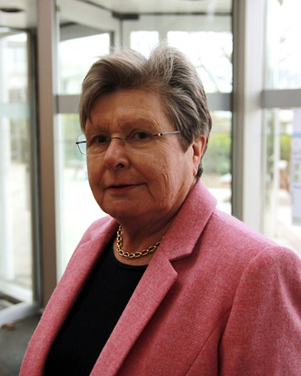
Chair of the Board of Trustees/Directors
Appointed February 2014
Ellen was one of the first women members of the Stock Exchange and the first in London to be taken into partnership by her firm. After taking five years out to go long distance sailing with her husband, Ellen became chairman of two publicly quoted companies, one in London and the other in Plymouth. She has served on various commercial and charitable boards including the National Maritime Museum Cornwall, Penair School and the board of the South West Regional Development Agency. For services to further and higher education, Ellen was appointed MBE in the 2012 New Year Honours. From 2014-2017 she was Vice Lord Lieutenant for Cornwall.

Peter Wroe
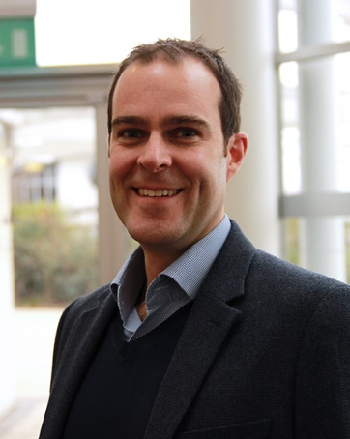
Trustee/Director
Chair of Audit Committee
Appointed April 2014
Peter moved to Cornwall in 2011 during a ten year career with BT Plc having held senior roles in finance, procurement, commercial, contract management, governance and public sector delivery. Prior to this Peter held a variety of senior financial positions in the health, contact centre and construction industries.
Peter lives in North Cornwall with his wife and children and is the Finance Director at the Eden Project.

Anita Firth
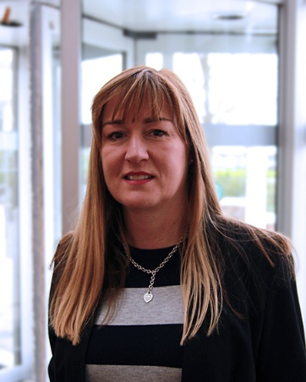
Trustee/Director
Appointed January 2016
Anita has spent her career in the teaching profession both as a senior school classroom practitioner and as a senior management team member in boarding schools in the independent sector.
A graduate of Warwick University, she started her career at a school in Surrey teaching Mathematics and Physical Education and quickly became head of department. She then moved to Hurstpierpoint College in West Sussex to expand her experience and responsibility by helping to oversee the introduction of girls to a previously all male boarding school and as a Housemistress overseeing the pastoral welfare of the students.
In 2004, Anita was appointed as Deputy Head at Truro School and as a member of the senior management team had responsibility for child protection and pastoral care matters. Having left Truro School in 2013 she has recently undergone training to join the ISI (Independent Schools Inspectorate).

David Williams
Trustee/Director
Appointed January 2016
David was educated in Reading and attended Westminster College. He took up his first teaching post at a secondary school in Leicestershire. He has led four successful secondary schools and Academies.
As coordinator for the National College Leadership Network in the West Midlands, an executive Head Teacher and a Local Leader of Education, David has contributed to the development of a number of schools and their leaders.
He is the Chairman of Trustees of the Discovery Schools Academy Trust with seventeen academies in Leicestershire.
He also serves as a Justice of the Peace in Leicestershire courts and as Vice Chairman of Governors for an outstanding local primary school.

Terry Lister
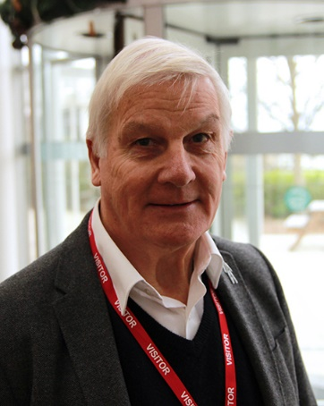
Trustee/Director
Member of Audit Committee
Appointed January 2018
Terry began his career in primary education in 1971. He moved to Cornwall in 1978 and was appointed Headteacher of St. Uny C.E. School, Carbis Bay in 1986. He remained there until his retirement in 2006, having been Chair of the Cornwall Primary Heads Association during 2003-4.
Since retirement, he has been a Governor at Chacewater School and became Chair in 2016. He is also Churchwarden and Treasurer at St. Paul’s Church in Chacewater.

Andy Stittle
Trustee/Director
Member of Audit Committee
Appointed May 2018
Before entering the teaching profession Andy worked as a research scientist and is a Fellow of the Institute of Mathematics and its Applications with chartered mathematician status. Andy has worked in sixth form, tertiary and further education colleges and also for a local authority, holding a variety of senior posts. He has also been an Ofsted Inspector since 2002. Andy is currently the Director for Teaching and Learning at Truro and Penwth College.
- Company number: 08880841
- Privacy Policy
- Contact
© 2018 Truro & Penwith Academy Trust. All Rights Reserved

