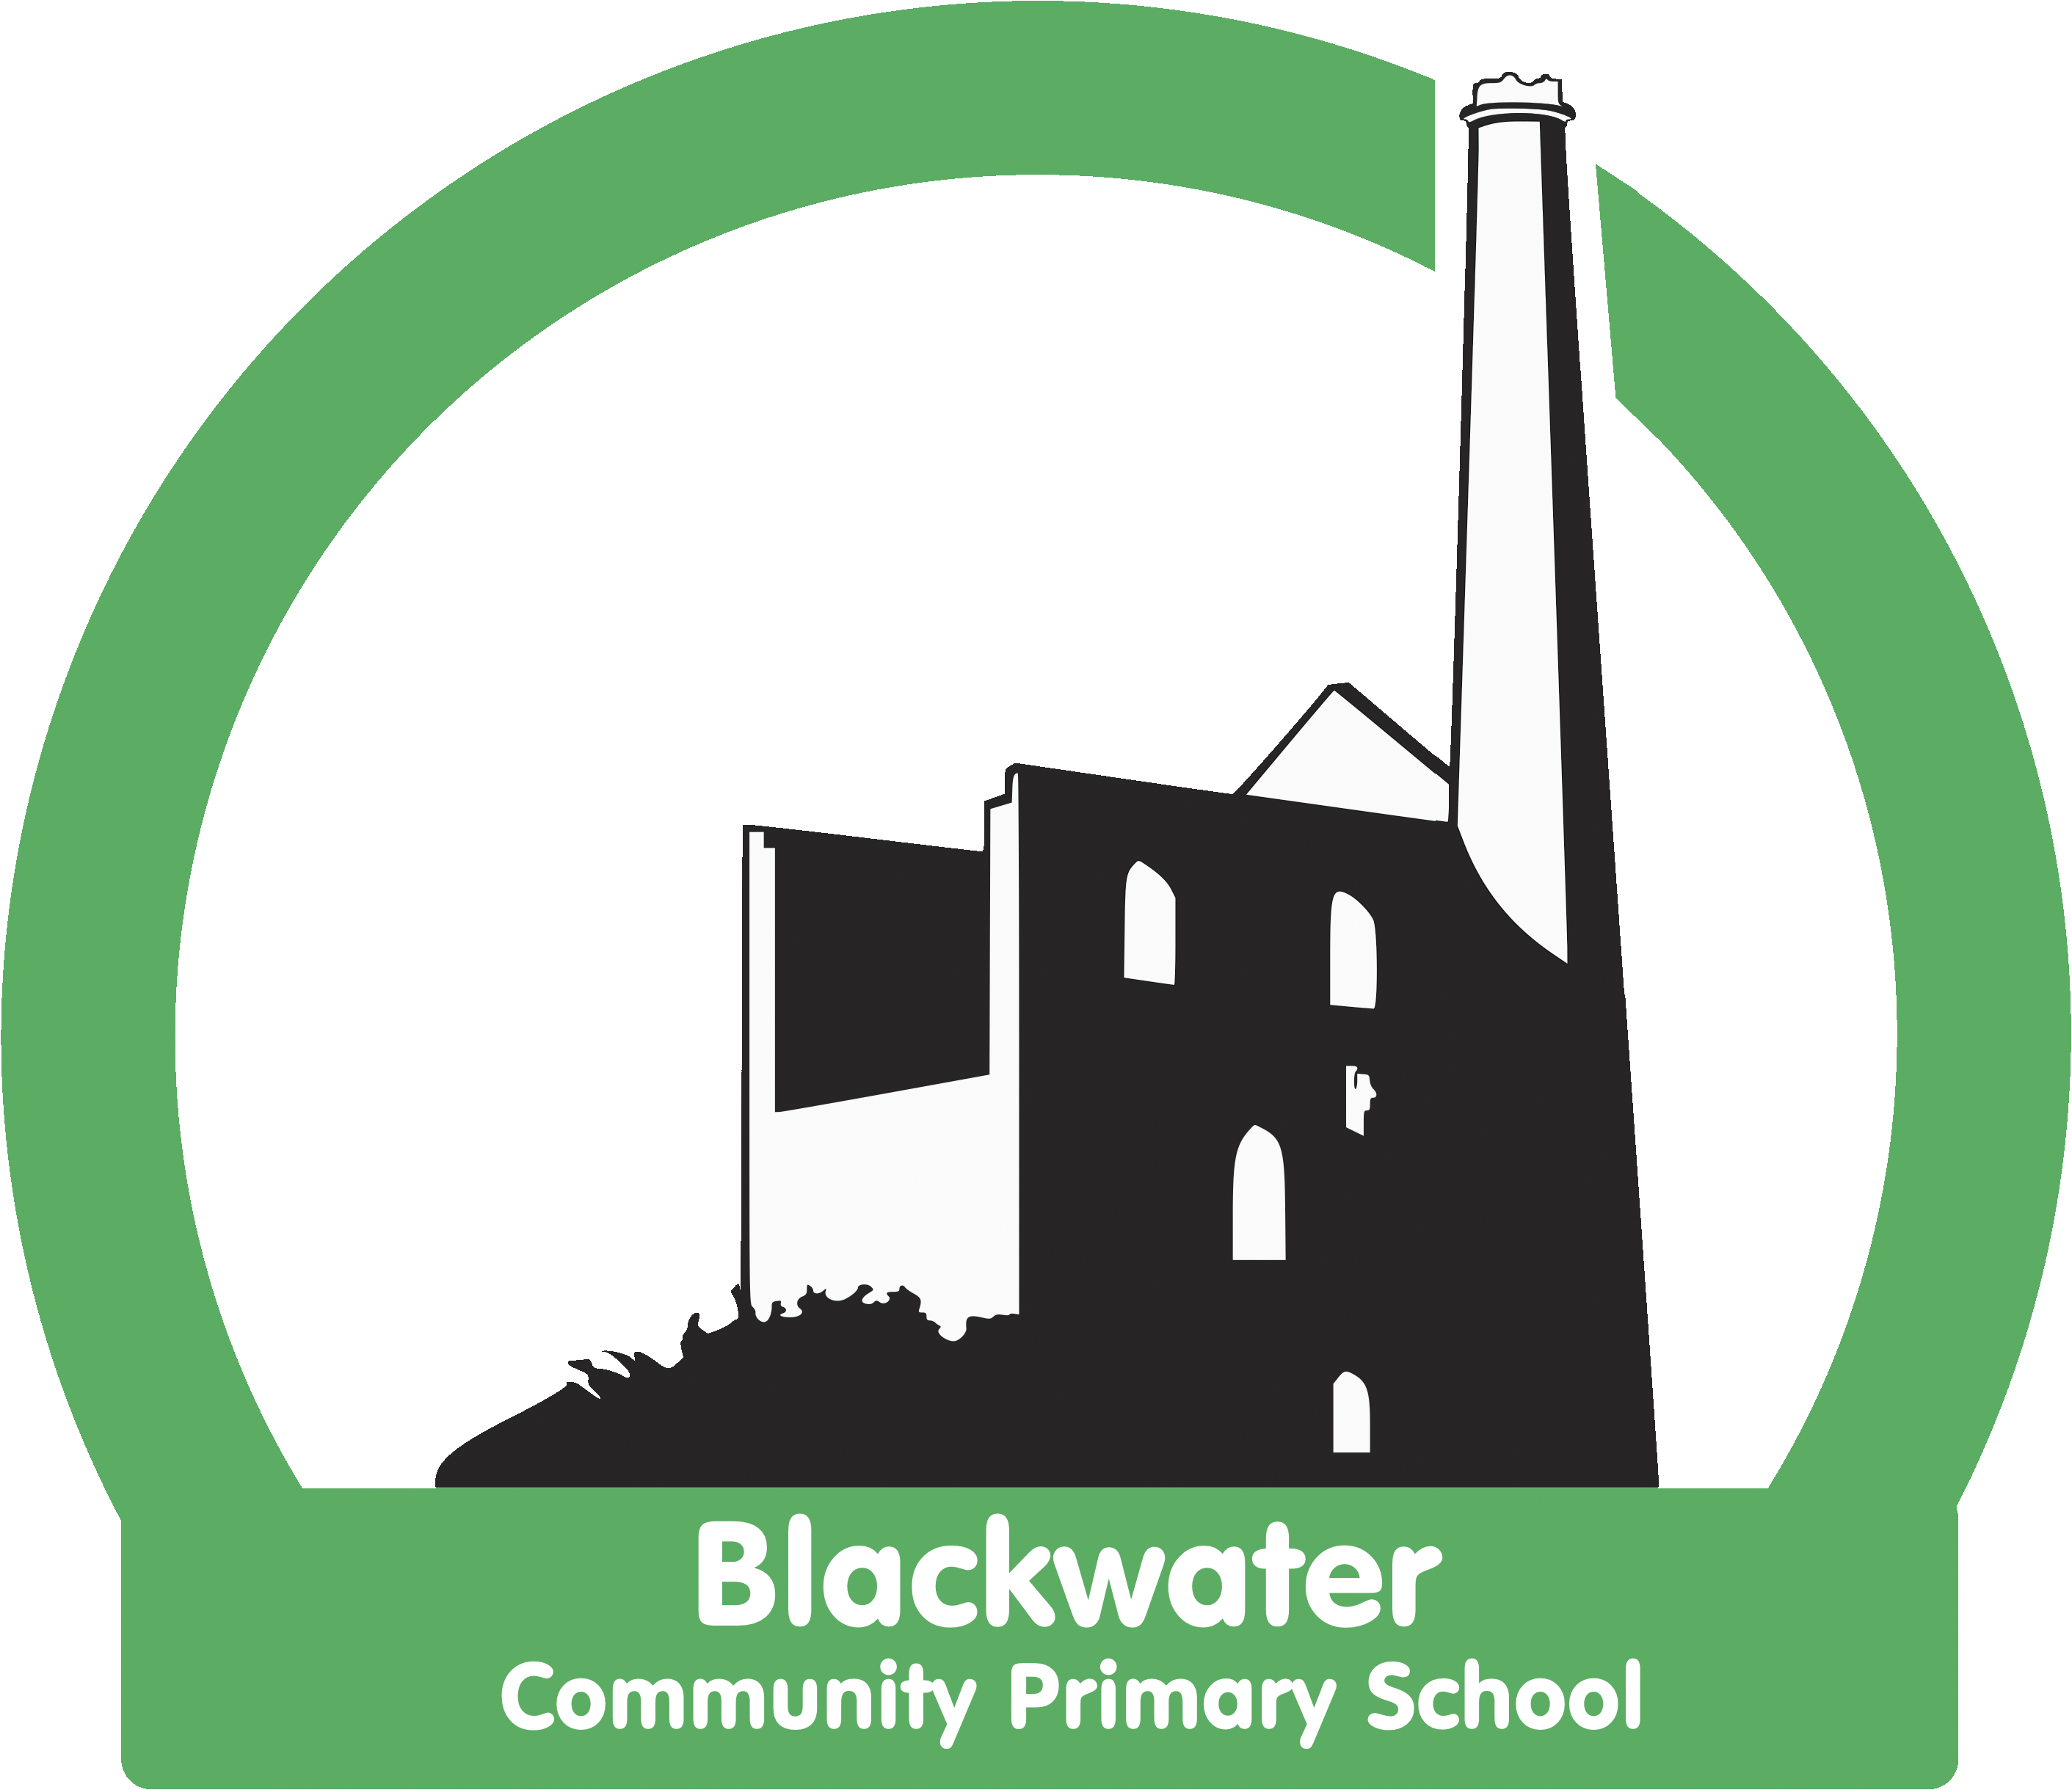

Blackwater Community Primary School
Health Questionnaire 2021
Please complete the questionnaire below and return it to school. It is important that all children with medical conditions are supported to make sure they are able to access their education. Please fill this form out, even if your child does not have any health concerns. Thank you.
Name of child……………………………………………………………………………Date of Birth: ……………………………….
Home Address: ………………………………………………………………………………………………………………………………..
Does your child have a medical / health concern?
YES NO
If YES please give details

Does your child have asthma?
YES NO
If YES please give details

Does your child have a medical condition/health concern that needs to be managed during the school day?
YES NO
If YES please give details

Does your child take medication during the day?
YES NO
If YES please give details

Does your child have a health care plan that should be followed in a medical emergency?
YES NO
If YES please give details

The above information is, to the best of my knowledge, accurate at the time of writing.
Signature(s) …………………………………………………………….. Print name……………………………………………..
Date: ……………………………………………………………………… Contact number ……………………………………..

