Wheal Harmony’s Weekly Overview 25th – 29th th JanuaryYEAR 1/YEAR 2
 | Monday | Tuesday | Wednesday | Thursday | Friday
Reading focus | Optima ar  Suffixes – al  Do a little word reading and reading with your adult every day.  (10 minutes reading for pleasure each day) | Optima qu / ar  Suffixes –age - al  Do a little word reading and reading with your adult every day.  (10 minutes reading for pleasure each day) | Optima qu / ar  Suffixes –age - al  Do a little word reading and reading with your adult every day.  (10 minutes reading for pleasure each day) | Optima qu / ar  Suffixes –age - al  Do a little word reading and reading with your adult every day.  (10 minutes reading for pleasure each day) | Optima qu / ar  Suffixes –age - al  Do a little word reading and reading with your adult every day.  (10 minutes reading for pleasure each day)
Vipers /Book Talk  (Daily video) | VIPERS  Listen to story in Scots  (The three wee pigs)  https://www.youtube.com/watch?v=lxMyJLSqRoY | VIPERS  Read the non chronological report on astronauts. | VIPERS  Tim Peake reading comprehension.  (See learning pack)) | VIPERS  60 Second Read  Space Theme
Phonics focus | Review sounds to date  / ar  Word Mat 5 CEW (Home)  Optima suffixes -al  Common Exception Words  (See Word mat in learning pack) | Review sounds to date  / ar  Word Mat 5 CEW (Home)  Optima suffixes -al  Common Exception Words  (See Word mat in learning pack) | Review sounds to date  / ar  Word Mat 5 CEW (Home)  Optima suffixes -al  Common Exception Words  (See Word mat in learning pack) | Review sounds to date  / ar  Word Mat 5 CEW (Home)  Optima suffixes -al  Common Exception Words  (See Word mat in learning pack) | Review sounds to date  / ar  Word Mat 5 CEW (Home)  Optima suffixes -al  Common Exception Words  (See Word mat in learning pack)
Common Exception Word  Read/Write | Over  who | too  whole | came  any many | will  clothes | Review all  Review all
Spelling focus | ar  -al  Segment and write  Spelling Shed | ar  -al  Segment and write  Spelling Shed | ar  -al  Segment and write  Spelling Shed | ar  -al  Segment and write  Spelling Shed | ASSESSMENT  ASSESSMENT
Letter Formation/ | Enemy letters  B and d | Enemy letters  p and g | Enemy letters  k and q | Enemy letters  M and n | Review All
SPAG  Vocab | Vocab: astronaut , orbit,
Writing links | Year 1: https://teachers.thenational.academy/units/instructions-how-to-make-a-paper-crown-aa36 (Instructions)  Year 2: https://teachers.thenational.academy/units/baba-yaga-openings-0ab9 {Story Openings )
Writing  CP=  Continuous  Provision | Year 1  (See Oak Tree Academy Link)  Lesson 1-  Year 2  (See Oak Tree Academy Link)  Lesson 1 | …  Year 1  (See Oak Tree Academy Link)  Lesson 2  Year 2  (See Oak Tree Academy Link)  Lesson 2  . | Year 1  (See Oak Tree Academy Link)  Lesson 3  Year 2  (See Oak Tree Academy Link)  Lesson 3 | Year 1  (See Oak Tree Academy Link)  Lesson 4  Year 2  (See Oak Tree Academy Link)  Lesson 4 | Year 1  (See Oak Tree Academy Link)  Lesson 5  Year 2  (See Oak Tree Academy Link)  Lesson 15
Mathematics focus  (using the White Rose) | Add by counting on  https://vimeo.com/490879463  x5 table  https://vimeo.com/490421314 | Add ones using number bonds  https://vimeo.com/490879867  x10 table  https://vimeo.com/490421912 | Find and make number bonds  https://vimeo.com/490882337  Making Equal groups  https://vimeo.com/492603273 | Add making 10  https://vimeo.com/492195041  Making equal gropus Sharing  https://vimeo.com/492603633 | Recap learning  99 club  99 Club
Mental Stragegy | Log on to Maths Factor  How many seconds in one minute  https://teachers.thenational.academy/lessons/measuring-time-in-minutes-and-seconds-68vp6c
Cross Curricular  Cross curricular. | 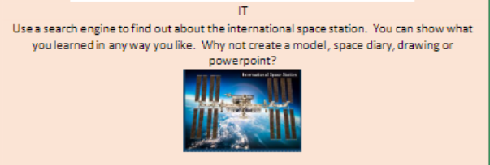  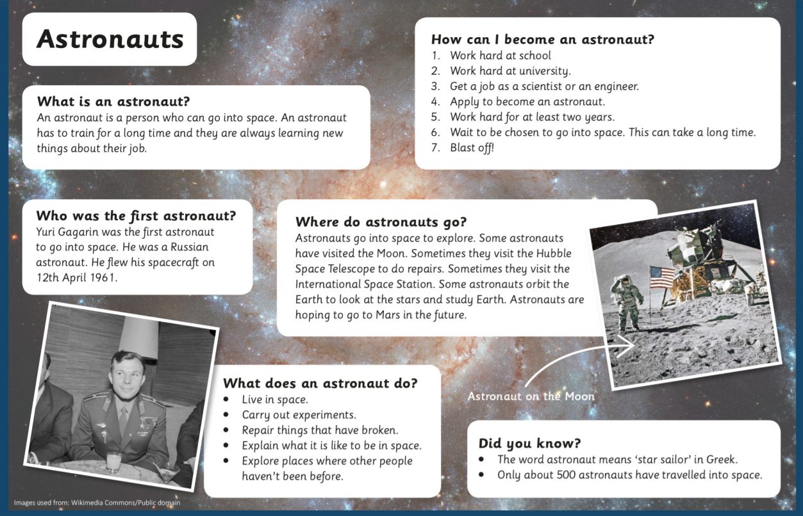  How do you become an astronaut? Check out these super cool video links to find out about life in space. What happens when you cry in space?  Find out about space walking. How do you eat in space?  https://www.sciencekids.co.nz/videos/astronauts.html
PSD | Check out this link for mindfulness activities to try at home.  https://www.bbc.co.uk/cbeebies/curations/mindfulness-for-children

Any questions, please contact me on Seesaw or email me on fiona.shuttleworth@blackwater.cornwall.sch.uk

