**Topic**

This term our learning revolves around our class book. We are going to be exploring the history of space exploration and astronomy. We will look at the Earth from space and take an aerial view of our planet and civilisation using satellite photography. 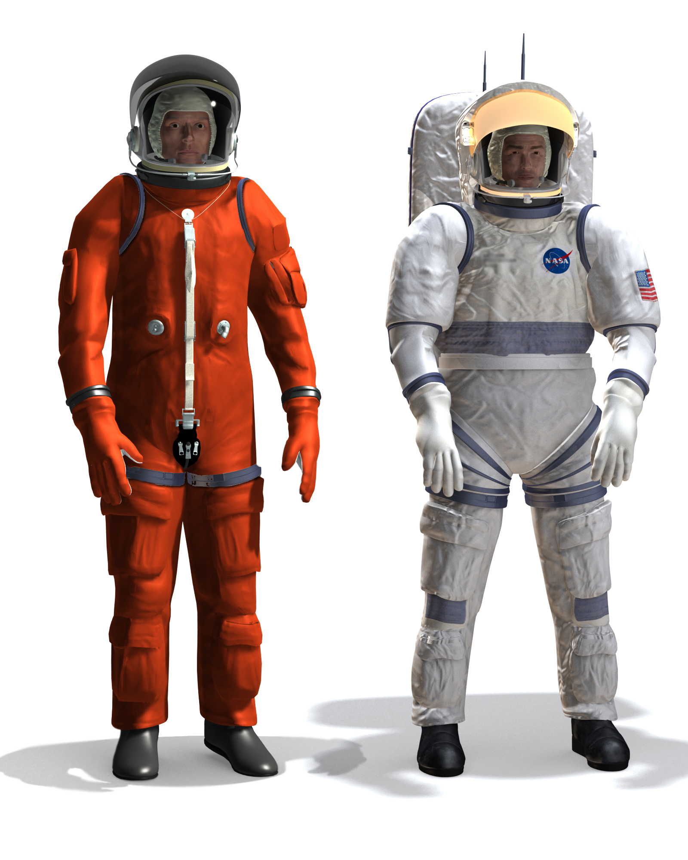 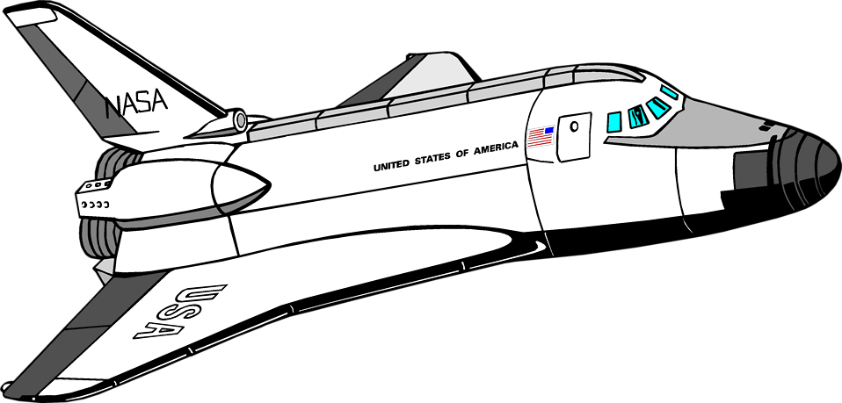

**Design Technology and Art**

Art will be led by Mrs Mannion again this term and children will explore space and universe themed art in mixed media. In technology we will look at spacesuits and take a problem solving approach to how to keep things alive in space!

**English**

Children will have daily vocabulary, reading, spelling, handwriting and grammar work. As our topic revolves around a book, we have plenty of opportunities for writing fiction and non-fiction from this. Think sci-fi stories, postcards from space, rocket manuals and instructions for living in space as well as fact files on planets and black holes!

**PSHE**

Children will explore resilience and motional/mental health and wellbeing.

**Science**

This half term we are looking at all things space! We will explore Nebulas, dust clouds, gas giants, binary stars and all manner of floating space junk! We will focus on researching planets, gravity, air resistance and rockets! All in all an action packed half term!



**“George’s Secret Key to the Universe” by Lucy and Stephen Hawking**

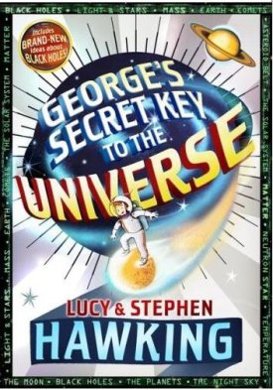

**Languages**

This half term we will have a fully immersive “Spanish Day” to explore the culture and language of Spain!

**Physical Education**

We have introduced the “Real PE” scheme across the school. It is an approach that looks at team games as well as individual skill, and creates opportunities to learn new skills and apply them in a whole game situation.

**Maths**

Children will explore reasoning, problem solving and mental arithmetic daily. We will continue to work on developing accurate and speedy recall of times tables and division facts, and will now include word problems with this. Our main focus this term will be shape, space and measure including working with and calculating angles.

**RE**

Class 4 will be looking at Christianity and scripture this term. We will discuss and think about what makes a good leader and how this helps us in difficult situations.

**Computing**

In computing this term we are drawing attention to the importance of internet safety for all of us.

