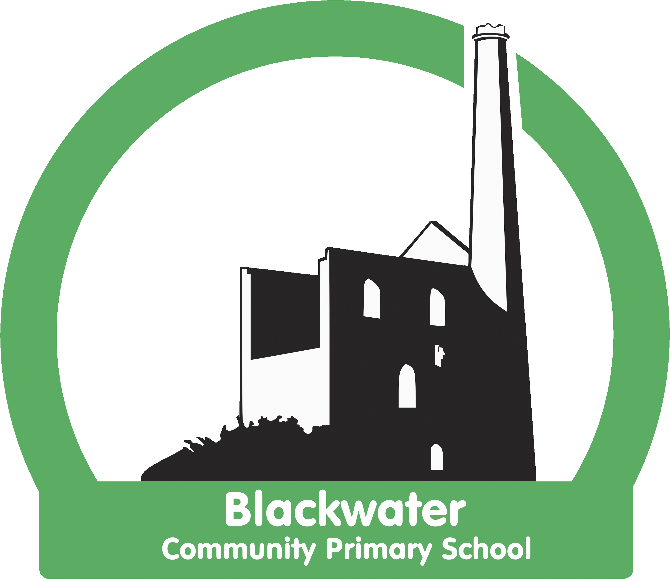

Blackwater Reading Strategy
2021 - 2022

Statement of Intent
It has been proven, through intensive international academic research, that the greatest indicator of future life success is children’s ability to read for pleasure.
Therefore at Blackwater we are committed to ensuring that all our children learn to read fluently, with understanding, and are passionate about reading, so that they have the greatest chance of success in the future.
We place a high priority on reading as we believe it is the cornerstone to all learning. We provide opportunities for our children to read across the curriculum and to deepen their knowledge in other subjects by reading non-fiction books.
We aim to provide children with a range of quality reading material and experiences with the aim of encouraging them to become independent, enthusiastic and motivated readers and to see reading as a positive experience.
At Blackwater, we all understand that cognitively there is no reason why a child can’t learn to read and to enjoy reading. We also understand that barriers exist for some children. We believe in all of our children, no excuses are made on their behalf. High expectation drives our passion for reading.

Statement of Implementation
All staff have high expectations of children‘s reading and believe that they are capable of success.
Our whole school approach to the teaching and learning of reading involves the following:

EYFS
- In nursery, children build skills of phonological awareness through daily teacher led sessions.
- The initial focus for developing early reading skills is communication and language. Continuous provision reflects this with the provision of communication friendly areas.
- In reception children begin by learning the letter sounds through daily phonics sessions. Phonics and reading skills are applied to the reading of real texts in whole class teacher led sessions.
- Children are encouraged to read independently through continuous provision, with a range of books available inside and outside.
- Extension and catch up sessions are planned weekly following informal ongoing assessment during phonics teaching.
- Books linked to topics are displayed widely in the learning environment.
- Comprehension skills are taught daily alongside phonics and word reading and through a weekly book talk session.
- Children take part in weekly paired reading with children in year 5 and 6.
- Children are read to daily; they join in with rhymes and singing.

Optima reading
We use the Optima reading programme to teach phonics.
‘Optima Reading is a research-based programme that has been developed through a series of studies over the last 20 years and has been shown in multiple evaluations to have a huge impact in raising students’ attainments. On average, students make 12 months’ progress in 6 months and the incidence of reading difficulties has been reduced from the typical 20-25% to less than 3%. ‘
- Through the Optima reading programme the skills of phonological awareness, phonics and sight-reading are taught daily and systematically. With daily opportunities to consolidate previous learning.
- Within Optima, children are then taught to apply their learning to real books, with daily sessions on vocabulary and comprehension.
- Optima reading sessions last 20-30 minutes, with further opportunity to enter into discussions about the text.
- Children are reading real books, therefore they are reading for pleasure alongside building their fluency.
- We love teaching reading in this exciting way, which celebrates books, builds self-esteem and promotes reading for enjoyment.
- Children practise their reading at home with phonically decodable books from Oxford University Press.
- The Optima reading programme is taught to children from the beginning of reception year, throughout key stage one and in key stage two to children who are at a reading age significantly below their chronological age.
- Our teachers are taught about the theory of learning to read, not just to deliver a programme, so we are able to adapt to our pupils.

Independent reading
- Children practise their reading skills daily.
- Children in EYFS are encouraged to read independently during their own learning time. Fiction and non-fiction texts linked to their cross-curricular learning are available.
- Children in year one have the opportunity to read independently at least once a week.
- Children in year two and key stage two read independently daily. The class reading areas are stocked with a range of poetry, non-fiction, cross-curricular topic related books, comics, magazines and newspapers.
- Children’s reading books are matched to their reading ability through the Accelerated Reader programme. Children are assessed half termly using the STAR reading test and through this matched to a reading level. Our reading books are stored centrally, in the library, and children are taught to change them independently.
- We have a member of staff who is a ‘Reading Champion’. She tracks the reading of children on Accelerated Reader and intervenes where needed (e.g. children not practising their reading at home.)

Reading comprehension
- We use the VIPERS question stems to ensure coverage of the content domains for reading.
- We begin developing reading comprehension skills from the very beginning of nursery, using a range of pictures and picture books.
- All children take part in a weekly book talk session, in which they are encouraged to use sentence stems to talk tentatively about texts (Based on Aiden Chambers’ ‘Tell me…’) Book talk sentence stems are displayed in each classroom.
- In key stage two (plus some children in year 2) children’s comprehension skills are assessed through Accelerated Reader. Teachers focus Accelerated Reader time on children who have reading fluency but poor comprehension skills.
- Children in key stage one and two are taught comprehension skills by the teacher daily through reading of the shared text and VIPERS. Children taught in Optima sessions are taught to answer VIPERS questions linked to the text.
- In year 2 children practise reading comprehension skills orally with the class teacher, with some follow up in reading journals.
- Year 2 and 6 children prepare for national SATs tests with weekly SATs style questions.

Reading for pleasure
- Promoting reading for pleasure in all our children is shared by all staff as our key priority.
- Children enjoy the fact that adults ‘trust’ them with real books.
- Children are taught to enjoy the privilege of being read to daily, including poetry, fiction and non-fiction texts.
- Children enjoy paired reading. A weekly session when older children read with younger children.
- Children are provided with an extensive range of reading material: a well-stocked, central library, reading areas in every class, newspapers, comics and magazines are all available in key stage one and two classrooms.
- We subscribe to the local library service and make good use of their delivery of cross-curricular topic related boxes of books. We also regularly change our high-low books through the library service.

Assessment of reading
- In EYFS children are assessed through observations during own learning time and a half termly phonics screening check.
- Children’s reading age is assessed in October, February and May and used to track progress and inform teaching.
- The reading age of SEN children is assessed half termly and used to inform interventions.
- In year one, children are assessed half termly using the standardised phonics test.
- Reading comprehension is assessed using the NFER test at the end of each term from year two to six.
- Practise SATs papers are used to assess year 6 children once every half term.
- Assessments are analysed and priorities set.
- Data is tracked half termly on Insight.

Disadvantaged/struggling readers
- The Optima reading programme is used to systematically practise reading fluency and comprehension in pupils who have fallen behind.
- Vocabulary is taught alongside reading skills.
- We have recruited volunteers, as well as our Reading Champion who practise reading skills with children who do not have this privilege at home.

Reading at home/ reading books
- We expect children to read for a minimum of 4 times weekly at home. In EYFS and KS1, this is recorded in reading records and checked by school staff every Friday. In KS2 home reading is recorded on the GoRead app, this is checked in school every Friday. Children are rewarded with 5 dojos for every home read.
- Children being taught Optima phonics take home phonically decodable reading books from Oxford University Press to practise their reading skills.
- Children who select their books through Accelerated Reader do so independently, this is tracked by our Reading Champion to ensure children are reading at their level and are enjoying what they read.
- Children select from our library of non-fiction books a book to enjoy reading at home. They visit the library at least once a week.
- The role and expectations of the parent with home reading are explained through a workshop and letters home.
- Children who are not reading at home will be supported by reading to peers or adults in school. Parents are spoken to and encouraged to support their child at home. Our Reading Champion keeps track of children who are not reading at home and intervenes.

Statement of Impact

Our school is clearly one where reading is a high priority. On entering the school, visitors are greeted by our beautiful library and displays which celebrate children’s reading. Moving around the school, our welcoming reading areas and book shelves show the importance of books in all of our learning. All these aspects have helped to create a positive reading ethos and an understanding of the need to learn to read in our children

The adults work endlessly to encourage a can-do attitude in our children and this can be seen by the children’s enthusiasm when choosing books, independently reading, sharing texts with others and enjoying being read to. Our children all see themselves as readers and demonstrate a love of books, even our most disadvantaged pupils.

