**Design Technology and Art**

After our voyage down the Fal, children will be exploring boat design. We will be looking at how boats float, and what designs are common in the river Fal and also the Amazon River.

Mrs Mannion will be leading art this term and will be based around comparative art in Britain and South America.

**Topic**

We will be comparing and contrasting the physical and human features of the Fal river and the Amazon river. In our history work we will also be looking at mining in Cornwall, and mining around the world as Cornish miners left Cornwall to work in mines, in South America in particular. 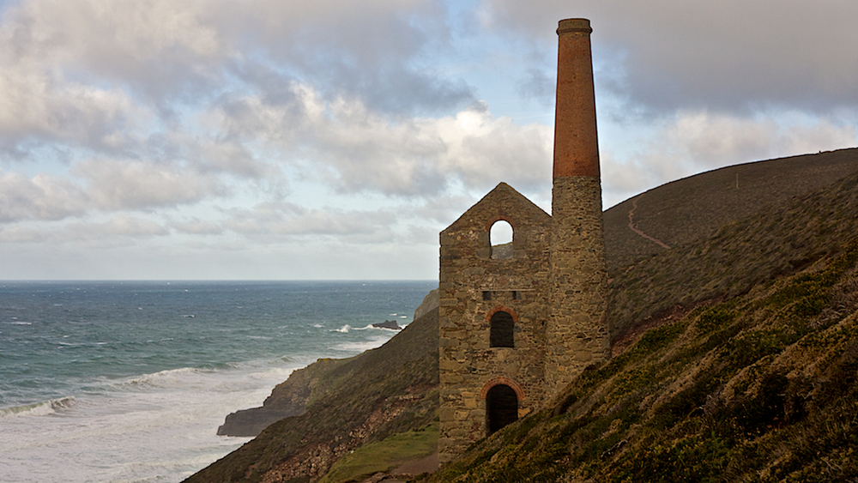

**English**

Children will have daily vocabulary, reading, spelling, handwriting and grammar work. This half term we will be reading “Wonder” by R. J Palacio. We will be exploring letter writing, and narratives from other cultures. In poetry we will be exploring War Poetry for Armistice day. In non-fiction we will be writing instructional texts.

**Science**

We will be having daily thinking scientifically sessions, and our lessons will revolve around light and how we see. We will look at the structure of the eye, light and the visible and invisible spectrum including wavelengths. We will also look at light-speed, light years and what this means!

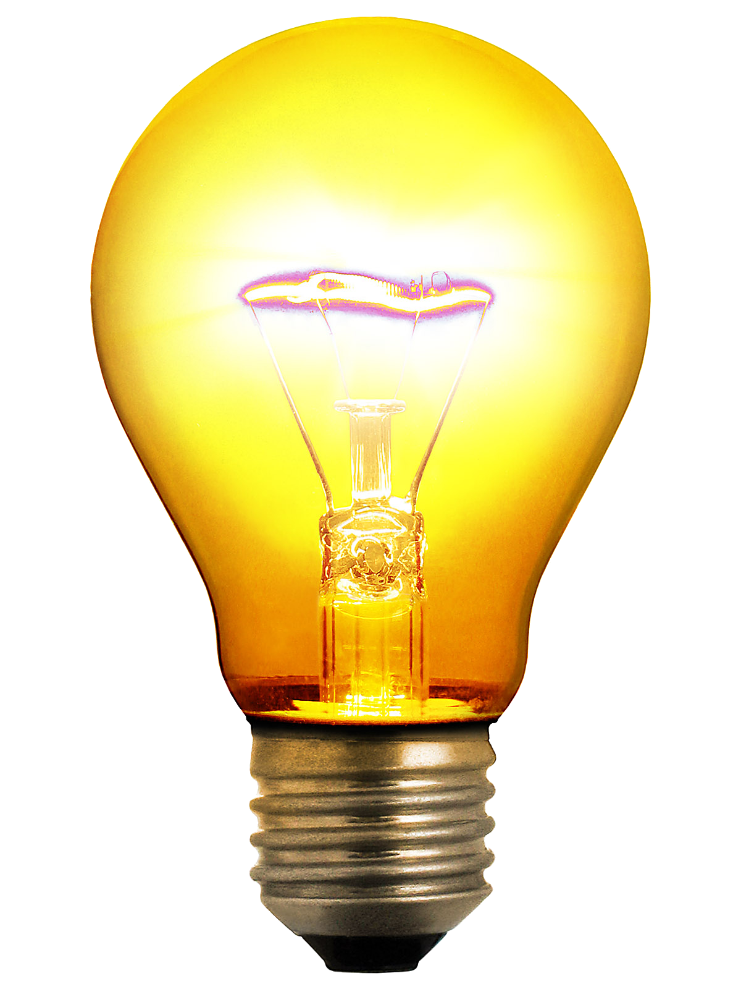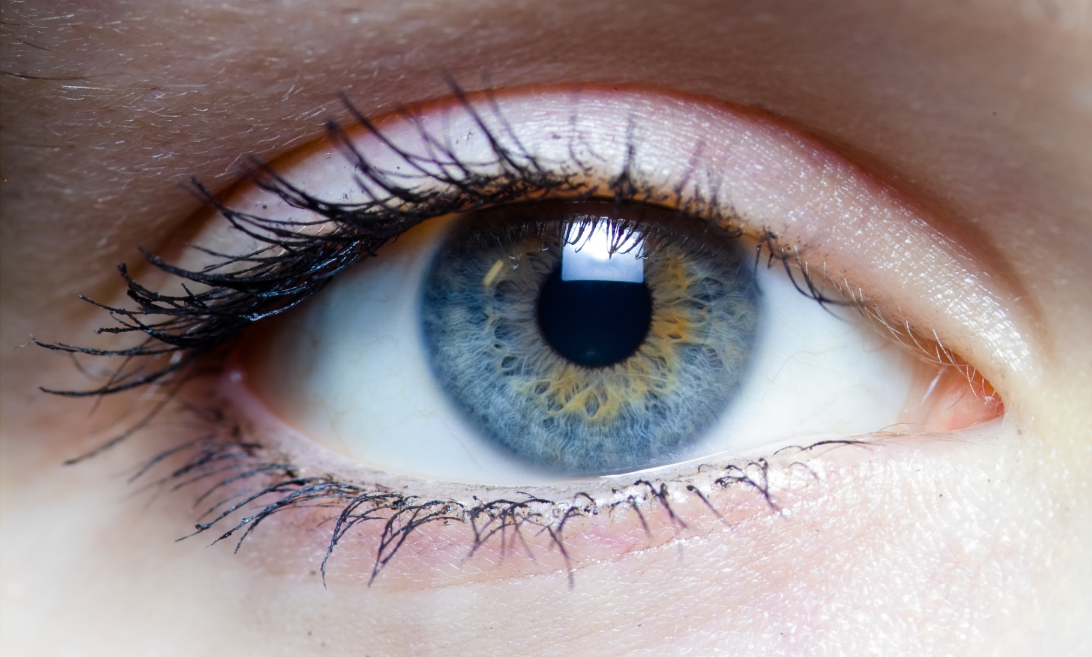

**Languages**

We are continuing to learn Spanish. This half term the focus will be on written and spoken language, telling and writing stories as well as songs. We will also sing traditional Spanish Christmas carols.

**“Home and Away”**

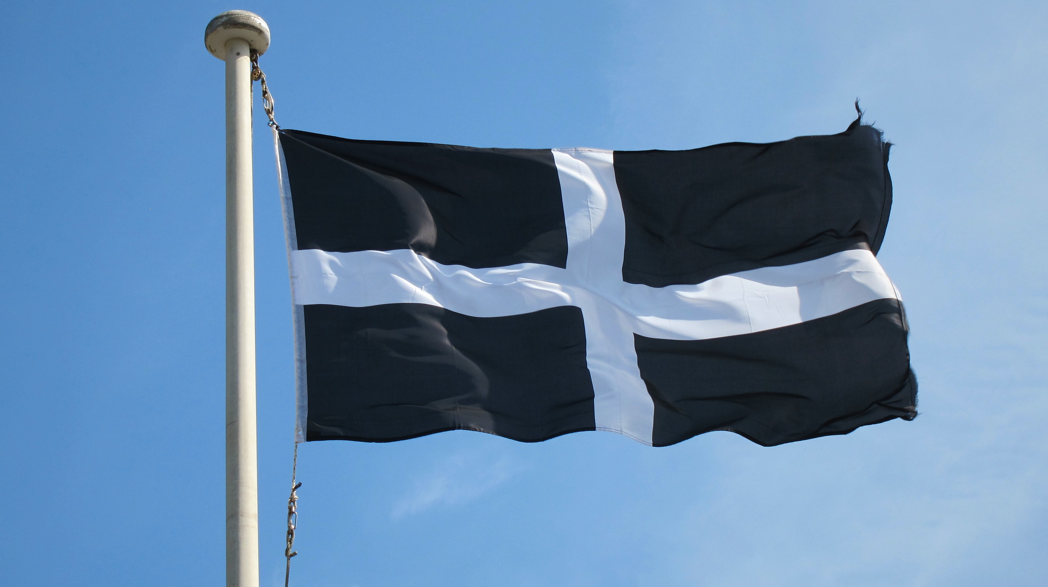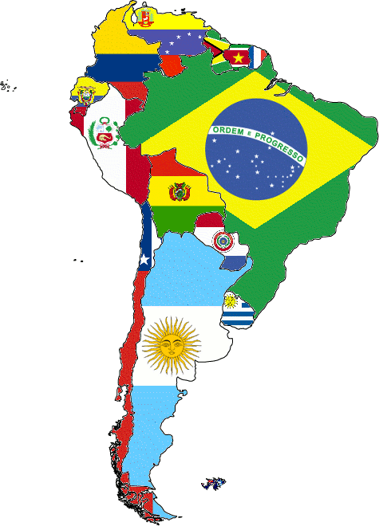

**Physical Education**

This term we will be having daily Yoga or skipping sessions. The children in year 5 will be using the sports facilities at Truro College and have sessions run by the sports leaders there.

**Mathematics**

This half term we will be calculating and problem solving with all four operations. Children will begin to start unpicking complex word problems with several steps. They will explore written division and applying division in context.

**PSHE**

Children will be looking at getting along with each other. This will explore emotional literacy and taking steps to manage difficult feelings and situations.

**Computing**

Children will consider digital wellbeing and what our individual rights and responsibilities are. We will do an individual audit to identify what we know. We will also be looking at fibre optics, and internet protocols like HTT and even VOIP.

**RE**

We will be exploring Divali and Christmas as festivals in our religious calendar.