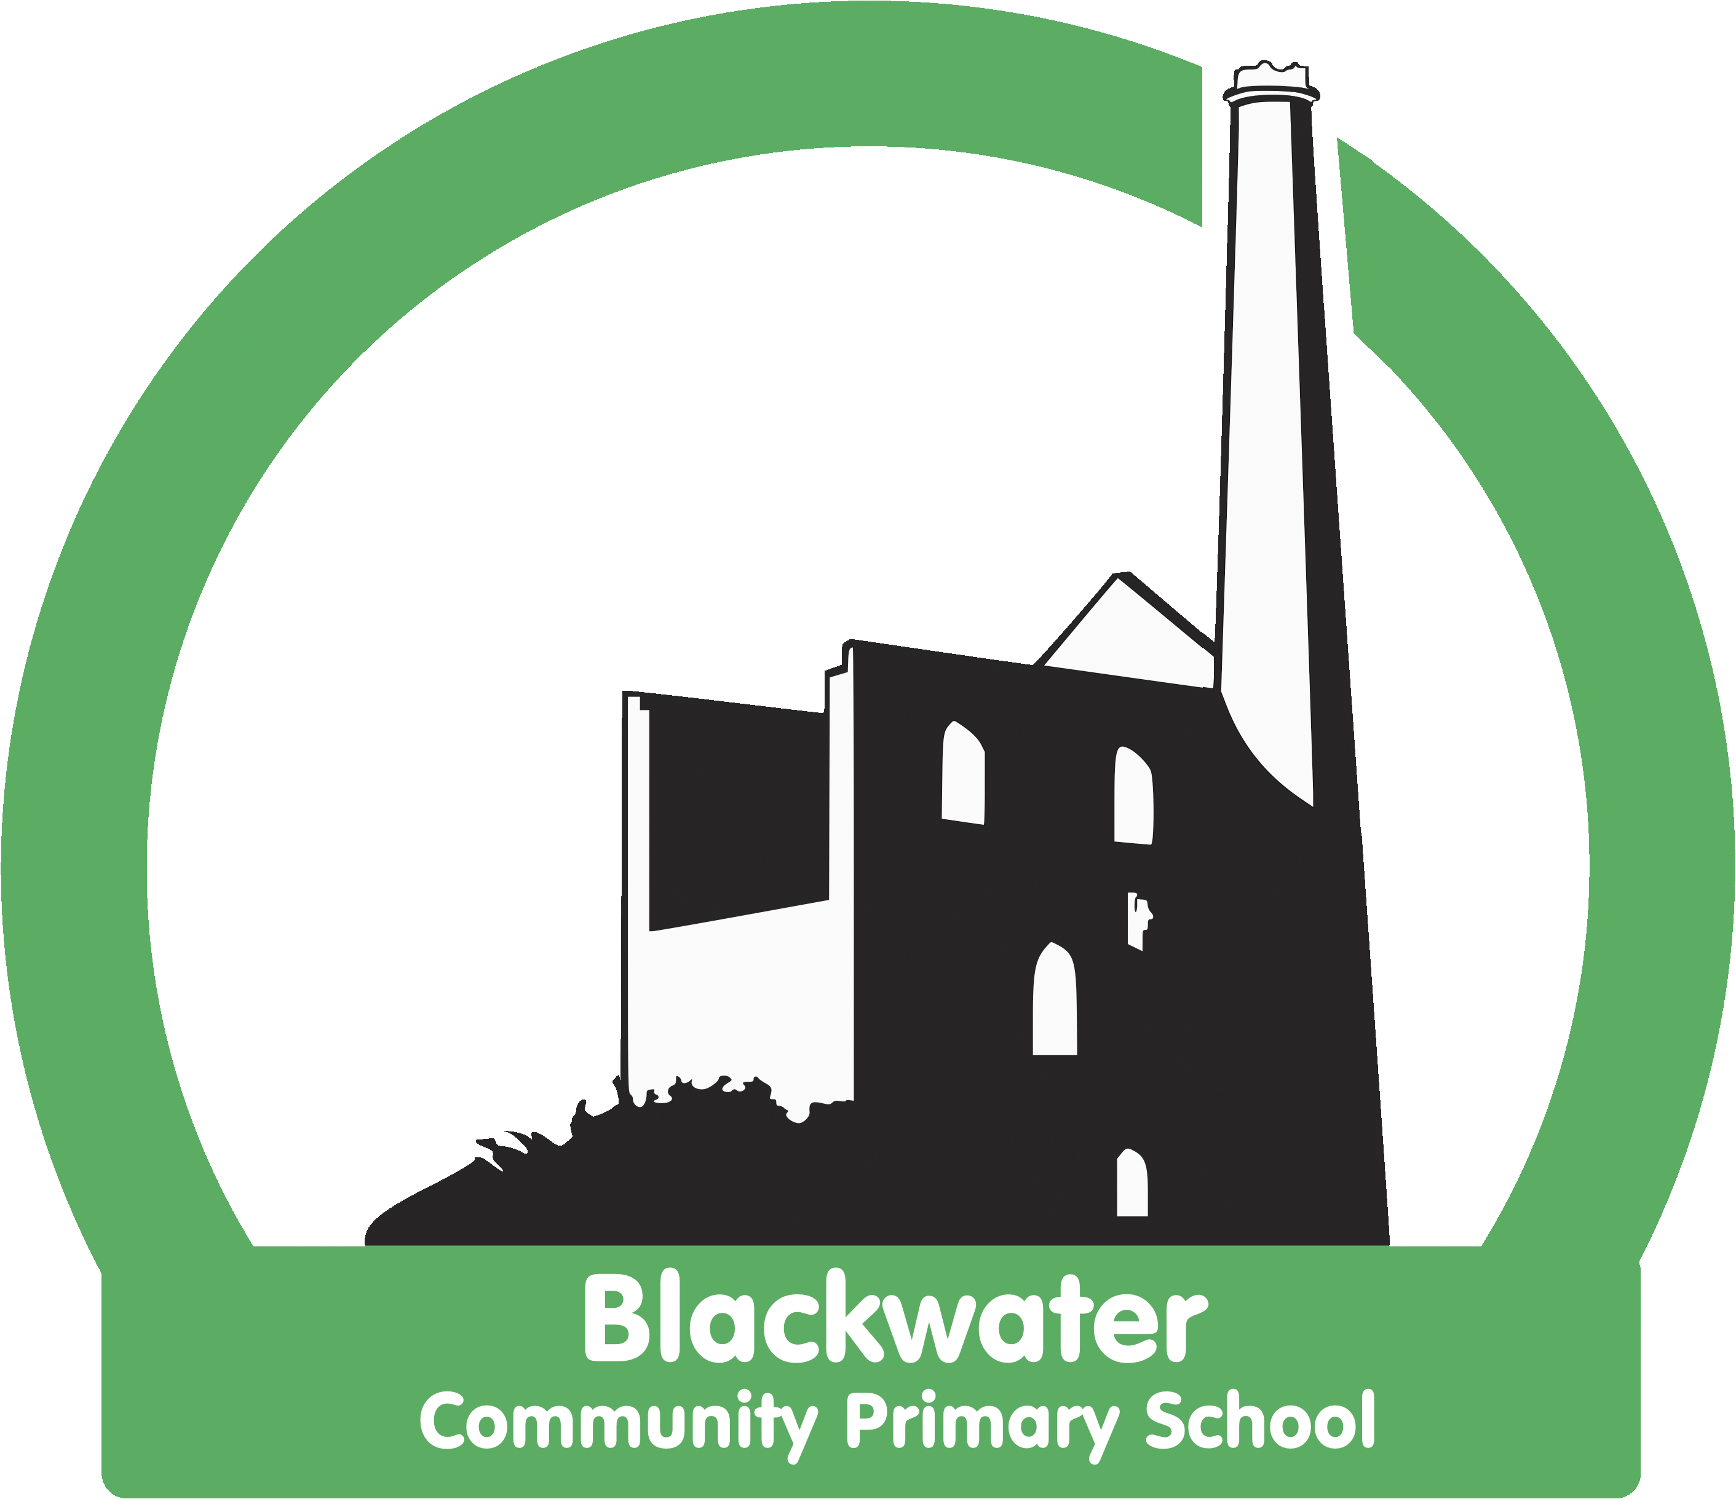

Blackwater Geography Strategy
2021- 22

Statement of Intent

“Geography is a subject which holds the key to the future” -

Michael Palin
At Backwater, we believe that Geography stimulates curiosity and fascination about the world and its people. We strive to equip pupils with knowledge about diverse places, people, resources and both natural and human environments, together with a deep understanding of the Earth’s key physical and human processes.
As our learners progress, their growing knowledge about the world should help them to deepen their understanding of the interaction between human and physical processes and of the formation and use of landscapes and environments. We study a range of significant figures in the field of geographical enquiry throughout the Key Stages and look at their contributions to our knowledge of the world we live in today.
We aim to develop confident learners, through exposure to a range of practical experiences, which build their geographical knowledge, understanding and skills enabling them to explain how the Earth’s features are shaped, interconnected and change over time. We encourage an inclusive school environment and ensure that all pupils, including those most vulnerable and those who are disadvantaged, have the opportunity to access the full and broad curriculum through carefully planned support and scaffolding as required.

Statement of Implementation
At Blackwater, all geographical work undertaken has been carefully organised to provide breadth and depth of knowledge and understanding as well as developing skills.
Beginning in Foundation Stage, our pupils are given opportunities to discover and learn about the world they live in. The Geography element of the children’s work is related to the Knowledge and Understanding of the World objectives set out in the EYFS Curriculum.
In Key Stage 1, Geography develops pupil knowledge, skills and understanding relating to their own environment and the people who live there and an awareness of the wider world, in accordance with the KS1 National Curriculum.
In Key Stage 2, Geography extends pupil knowledge, skills and understanding relating to people, places and environments in the United Kingdom and beyond, developing an appreciation of how places relate to each other and the wider world, in accordance with the KS2 National Curriculum.
Curriculum progression is clearly set out through Cornerstones Maestro, which has been structured to allow frequent opportunities for children to revise and review key facts and knowledge. Our carefully planned curriculum starts with children learning first about their local area and then using this knowledge to expand their thinking to look at the wider country and then the world and beyond. We feel it is very important for our children to develop a strong sense of community and develop a passion about the conservation and preservation of our local environment. This is why we try to make use of our local environment, as much as possible, in our teaching. It is important for us to teach our pupils about how to respect their local environment and what they can do to help. It is our hope that this respect in turn will transfer a better understanding and appreciation for environmental issues affecting the wider world.
A strong focus for teaching is the use of correct technical vocabulary. Teachers carefully plan the language they use during their sessions and model, through discussion, specific geographical vocabulary to help embed this language in the children’s long term memory. This is also reinforced through the use of Knowledge Organisers which are used to recap, revise and revisit key vocabulary regularly.
Teachers are provided with regular opportunities to develop their own subject knowledge through sharing good practice, peer observation and visiting experts.
Short assessments are undertaken by the children during and at the end of each topic to check for gaps and revise important facts if required. This information is then used to inform future teaching and for teachers to adapt and edit planning as required.

National Curriculum for Geography

https://www.gov.uk/government/publications/national-curriculum-in-england-geography-programmes-of-study/national-curriculum-in-england-geography-programmes-of-study

Statement of Impact
The impact of our Geography curriculum is that our learners are equipped with the geographical skills and knowledge that will enable them to be ready for the secondary curriculum and for life as an adult in the wider world.
The children will be able to discuss their learning and demonstrate their knowledge and understanding through a range of activities.
Outcomes in topic books evidence a broad and balanced Geography curriculum and demonstrate children’s acquisition of identified key geographical knowledge and skills.

