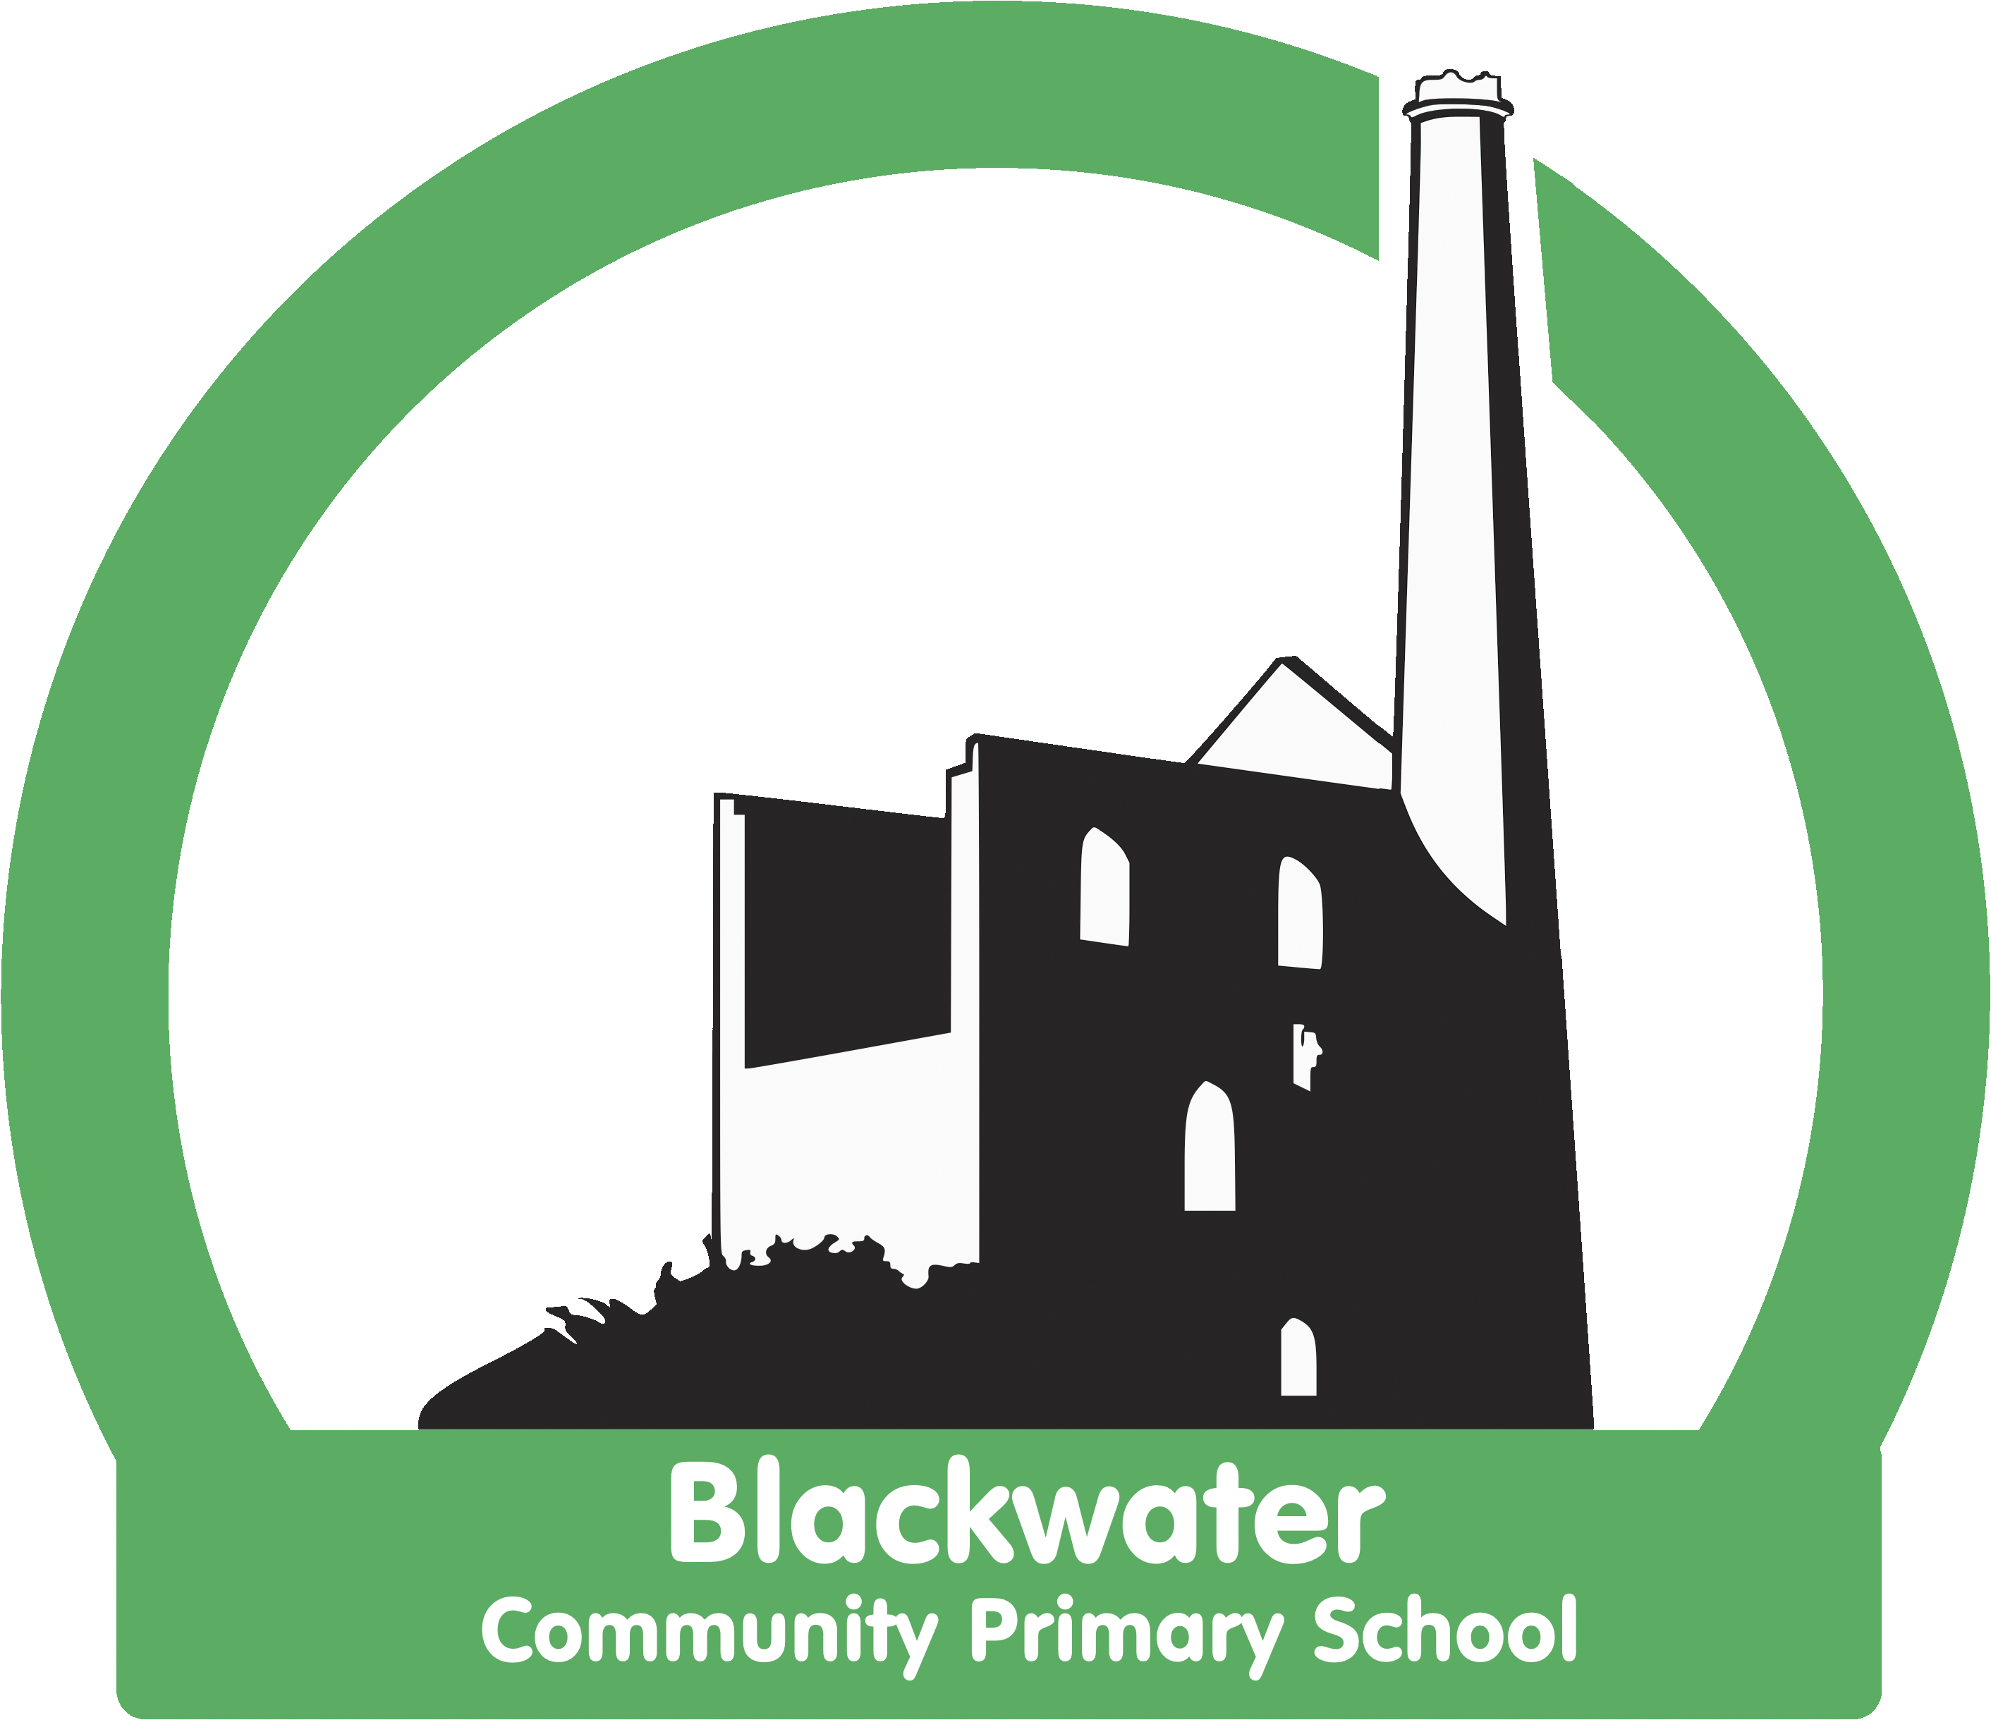

Blackwater Writing Strategy
2021 -2022

Statement of Intent
At Blackwater we are determined to develop an enjoyment for writing in all our pupils. We believe that if writing is taught in an exciting way, with enthusiastic teacher modelling then all children can be motivated to write. All staff understand that cognitively children are able to become competent writers if they are taught to see themselves as writers. We have high expectations of our pupils and teach them to have high expectations of themselves.
We place a high priority on writing and the building of skills daily. We understand that it is through an intensive programme involving the practising of skills that knowledge and understanding will become embedded and applied. We provide opportunities for our children to write across the curriculum in order to apply their writing skills to different purposes.
We aim to provide children with regular opportunities to write for a range of purposes, linked to our learning in other subjects. We believe that the more opportunities children have to write, the better they get at it. Our aim is for children to become independent, enthusiastic and motivated writers and to see writing as a positive experience.

Statement of Implementation
All staff have high expectations of children‘s writing and believe that they are capable of success.
Our whole school approach to the teaching and learning of writing involves the following:

EYFS
- In nursery, writing consists of gross and fine motor activities as well as continuous provision. There is a funky fingers area with fine motor activities available all day, every day. Children also dig, paint, and use sand and chalk to develop their motor skills. They practise mark making/ letter formation by writing in sand during handwriting practice.
- Reception children also have fine and gross motor continuous provision and funky fingers. The children write every morning when they first come into class; they have a daily handwriting/ letter formation lesson and complete a short writing session after Optima reading every day. They also do exciting writing in their books once a week.
- The EYFS class has a writing / mark making area in the classroom which is always available for the children to access the resources and weekly activities are included in that area. They also have a phonics table with activities changed weekly for the children to access during the day.
- Children in reception practise segmentation of words to spell them, alongside their phonics learning.

Handwriting
- We follow the KBER scheme for handwriting. Children are taught cursive handwriting from reception.
- Handwriting/letter formation is taught daily in EYFS and key stage one, 3 times a week in lower key stage two and for children who need further practice in upper key stage two.
- Children work towards ‘licences’ in their handwriting.; firstly a letter formation licence then a pen licence.
- Firstly children achieve a letter formation licence when they have mastered the correct cursive letter formation of all 26 letters.
- After that children work towards a pen licence, when their handwriting is of a consistent size, using the correct joins.
- When children have achieved their pen licence, adults demonstrate expectations to children that their handwriting needs to of a consistently high quality. Children work towards achieving a ‘sustained and consistent’ licence.

Spelling
- We follow the Spelling Shed programme in school and for practising spellings at home in key stages 1 and 2.
- As part of this scheme, children are taught, or revise, a weekly spelling rule by their teacher, or they learn challenge words. They then work on learning this spelling rule through independent tasks at least 3 times a week in school and the online assignment at home.
- Children are set both written and online tasks to work on their spellings.
- Spellings are tested weekly.
- Current spelling patterns being learned are displayed in classes on working walls as well as prompts to assist children with spelling. These vary depending on year group and may include: regularly used graphemes, common exception words, the spelling of age appropriate prefixes and suffixes or mis-spelt words from their writing.
- Children are taught to proofread their writing for spelling mistakes; they are provided with word mats, dictionaries or writing buddies to assist them with correcting spelling mistakes.
- Children are taught to segment words into phonemes and have a go at applying their phonics knowledge to the spelling of each syllable in turn.
- During whole class feedback at key stage two, spelling mistakes from children’s writing are discussed and addressed.
- Speedwrite, flash write, dictation, correct the mistake are methods used regularly to learn new spellings. Children are also taught to write a word which they are unsure of spelling several times and to identify which ‘looks right’.

Punctuation
- The use of punctuation is taught during shared writing. The teacher verbalises his/her thought process while writing, consistently demonstrating the correct use of punctuation. This may often include the teacher making ‘mistakes’ which the children learn to become eager in spotting and identifying.
- Children’s use of punctuation is assessed through dictation and independent writing tasks.
- In key stage two the whole class feedback session is used to highlight and address punctuation misconceptions from children’s writing.
- Children are taught to proofread their writing for punctuation mistakes.
- Working walls are used to display information to help children with their punctuation.

Vocabulary and grammar
At Blackwater we believe that developing children’s vocabulary daily, systematically and with high expectations is key to their success. We do this through:
- Teaching children a ‘word of the day’, often linked to their learning across the curriculum. They learn its meaning and word class and playing around with how to use it in a sentence. Words of the day are displayed in the classroom and children are praised for using them successfully in their writing.
- Regular vocabulary gathering prior to writing. Children are taught to use thesauruses and ‘Descriptosaurus’ (in Key Stage Two) in order to be able to use ambitious vocabulary in their writing.
- Staff model using high quality vocabulary in their writing. This is verbalised during shared writing, children are constantly prompted to offer powerful vocabulary to the shared writing process.
- Grammar is taught during the shared writing process. Staff constantly ‘drop in’ grammatical terminology to the writing process, such as ‘I am thinking of an adjective I could add into this sentence to make it more descriptive,’ or ‘I am looking for a synonym for cold.’
- Definitions of the grammatical terminology being taught are displayed on working walls alongside examples of them applied to writing, including in the children’s writing.
- Whole class feedback sessions in key stage two are used to address misconceptions in grammar.
- Writing lessons begin with a short vocabulary /grammar ‘warm up’ which is relevant to current learning in the class and feeds in to the shared write. All children contribute to this session, often writing their contributions on mini white boards. Children are never passive during this session but active and engaged.
- Children are taught to use word mats and working walls alongside their vocabulary and grammar learning.

The writing process: shared and independent writing
Central to all writing teaching at Blackwater is the use of the shared write. We strongly believe that it is through daily verbalising and modelling of the writing process that children will learn to be successful writers. We also believe that the more opportunities children have to write, the better they get at it.
- Shared writing involves the adult modelling the writing process while saying out loud what he/she is thinking while choosing words and sentence structures.
- Grammar, punctuation, vocabulary, sentence structures, features of text types as well as editing and improving are all taught through the shared write.
- We ensure that ALL children are active and contributing during the shared write by asking them to offer word choices or suggest improvements, while also spotting ‘mistakes’.
- Shared writes often involve the whole class but may also be with smaller, targeted groups in order to support or extend.
- The writing process always starts with a high quality starting point, including a text (or part of a text), an image, a film clip, a role play or an object. We subscribe to Literacy Shed Plus and look for where their resources complement our current topic learning, as well as using resources from the Cornerstones curriculum.
- All writing links to current topics and learning across the curriculum, as well as to special events and what is happening in the wider world.
- At Key Stage Two WAGOLLs are celebrated during whole class feedback and used to encourage children to edit and improve their writing. We have high expectations for all and celebrate the fact that WAGOLLs can come from any child in the class, despite their ability level. All children can succeed in writing at Blackwater.

Proof reading and editing
We understand that regular practice editing and improving writing will help children become better at it but that it is complex and needs to be taught explicitly and in small steps.
- Children edit and improve on a regular basis.
- There are many aspects to editing and this can be overwhelming. To begin with we have just one editing focus to work on at a time, such as spelling, punctuation or word choice. This is firstly modelled by the adults and then practised by children, either independently or with their writing buddies.
- Termly, we arrange children from across the classes to meet in mixed aged pairs to work on editing stations together. The older children become more adept at editing because they are explaining the aspects to be improved and the younger children become more adept at having one to one support through the editing process.

Writing across the curriculum
- All our writing links to our learning in other subjects, whether it has a Science, history, R.E., P.E, basis.
- Children write independently in Science and R.E. once a term.
- There will be evidence of children’s writing in the writing books and topic books.

Assessment of writing
- All children, from nursery to year 6 complete an unaided piece of writing half termly. These will be linked to our topic learning. Children will write independently following a prompt.
- This unaided writing is kept as a record of progress in children’s progress in writing folders and moderated by the staff at staff meetings.
- Children are regularly set an independent writing task, which they complete in their writing book, and is then edited and improved (see ‘proof reading and editing’ above.)
- Children’s writing attainment is collected termly from teachers using the Jason Hurr system.
- Pupil progress meetings and subject leader data analysis is used to track the progress of individuals.
- Spelling ages are assessed using the Single Word Spelling test at the end of each term (3 times a year.)
- Children complete the NFER grammar, punctuation and spelling assessments 3 times a year.
- Writing at reception, year two, year 4 and year 6 is moderated with colleagues from the multi-academy trust at least once a year.

Disadvantaged/struggling writers
- Teachers regularly conduct a shared write with children who are struggling with the concepts being taught.
- Precision teaching for spelling. Groups of children are taught spelling patterns in additional groups. They are taught spellings alongside the phonics taught in Optima reading.
- Some groups are taught spellings from previous years’ Spelling Shed.
- Class dictations are differentiated to assess children on the spelling and punctuation they are using and in order to plan next steps to move the learning on.
- Adults make use of multi-sensory spelling techniques when working with groups.

Statement of Impact

At Blackwater, our children have learned that they can all be successful in writing, all have contributed to a shared writing session, all enjoy looking back at their progress in writing folder to see the progress they have made, all have had their achievements recognised by a writing buddy and most have been celebrated as a WAGOLL at some point.

Our children learn to love words; playing around with them, experimenting with them, learning new words and dropping them into their talk, role play and writing. The adults model using ambitious vocabulary and our children pick this up and learn to have high expectations of themselves.

Our topics are chosen because of their interest and relevance to our setting, children become totally immersed in them. As our writing always links to our topics it is often enthusiastic and conveys interest, with a great deal of experience and knowledge behind it.

We all have a firm understanding that the more opportunities children have to write, with fun and interactive writing lessons, alongside high expectations, the better they will get at writing. This is evident in children’s contributions to writing lessons, our school environment and in children’s writing.

