List 1 to be tested 18/9/20 | List 2 to be tested 25/9/20 | List 3 to be tested 2/10/20 | List 4 to be tested 9/10/20
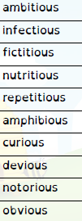 | 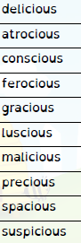 | 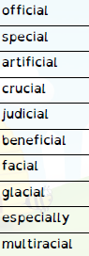 | 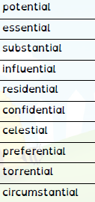
List 5 to be tested 16/10/20 | List 6 to be tested 23/10/20 |  | Please help your child learn these spellings using the look, cover, write check method each week ready for a test planned on the dates shown. If we have a school trip or visit, the test will go ahead at the earliest date possible after the planned test date.  If you have given consent your child will be able to go online to the Spelling Shed to help them learn and consolidate these spellings.  Many thanks.
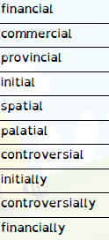 | 