Wheal Friendly’s Home Learning Overview- 25th January 2021
Out topic- Can I switch it on?
 | Learning Objectives for the Week | Activities and Links
Reading  DAILY | To share a book with a grown up or sibling. | - Share a book together at least once a day. This could be a school book or one from home.  Can they help tell the story or recap what it is about after you have read it?  - Practice reading our sight words- and, the, said, I, to and he  - Listen to the story Arnie the Doughnut by clicking the link below. https://www.youtube.com/watch?v=6E67n1vZZjQ
Handwriting  DAILY | To write the letter g | - Write the letters in a, preferably, yellow pen for your child to trace over and then give them the opportunity to write them independently.  We are learning cursive in school. Here are what the letters look like;  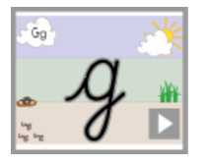  https://teachhandwriting.co.uk/continuous-cursive-beginners-choice-3.html  Clink on the link above to access short clips which model how to write the letters. The focus for this week is g only.  - Watch this video to show you how to write a cursive g  https://www.youtube.com/watch?v=YF5RnWZHf3w
Phonics  DAILY + Optima videos on Tapestry | To recognise and know the letter p | - Click on the link below to access a video of a song introducing the letter p  https://www.youtube.com/watch?v=yZjEtwr8Q4o  - Click on the links below for a video teaching the letter p  https://www.youtube.com/watch?v=Q8qklEXh7Dc  - Alphablocks- letter p  https://www.youtube.com/watch?v=zCPhZ7CGjKU
Writing  DAILY | To practice sight words | Use rainbow writing to practice writing the words I, no, go into, the, to  - Have a go at writing in shaving foam / baby lotion. Pop some on a plate and practice writing with your fingers  - Can you make sight word pebbles to help you practice? Collect five pebbles on the beach, can you write in painting pens or sharpies the sight words on each one?  - Can you write about the toys on the sheet?  - Exciting writing – Friday we will be having a go at another exciting writing sentence.
Mathematics  DAILY + Daily links for teaching videos, posted on Tapestry | Addition to 20  (By the end of reception, children should be able to write their numbers to 20 and count two numbers together less than 10) | - Have a go with the worksheets in the paper pack / emailed out to you.  - Can you make two groups of buttons and add them up? Can you write the number sentence to go with it?  - Can you use a number line to help you with your adding?  - Practice your 99 club – number formation making sure the numbers are the right way round.  - QUICK MATHS Jr APP to support counting.  - Numberblocks video – addition mission  https://www.youtube.com/watch?v=C6KDz2mAn9o  - Jack Hartman’s counting to 20  https://www.youtube.com/watch?v=_MVzXKfr6e8  - Our favourite Number Song – the children love it!  https://www.youtube.com/watch?v=e0dJWfQHF8Y
Topic  CHOOSE ONE PER DAY | Our topic this half term is Can I switch it on?  . | - Have a go with Google Maps. Can you find where you live? Can you find our school? Can you spot where New Zealand is? That is where Mrs. Evison used to live!  - Can you write me an email? Use your parent’s email address to write an email to me to say hello! head@blackwater.cornwall.sch.uk  - Can you make a cup phone? It’s a bit like a telephone. Does yours work?  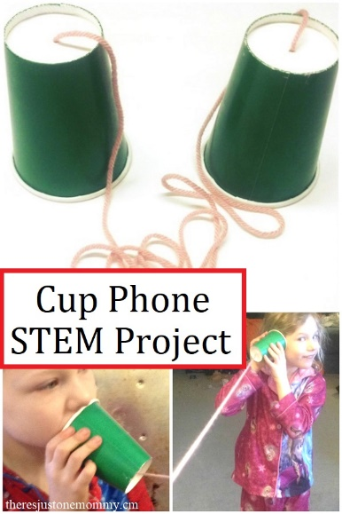  - Can you make your own projector? Use a toilet roll, some cling film and some stickers. Shine a torch through the roll, what can you see on the wall?  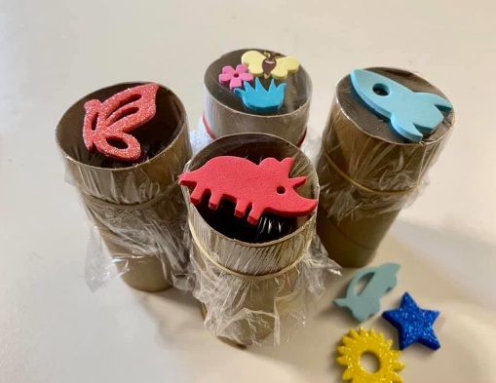  - Can you find letters on the keyboard? (See printed keyboard) can you tap out a word? Can you tap out cat, or dog, or happy!
Fun  DAILY |  | - IT IS RECOMMENDED THAT CHILDREN OF RECEPTION AGE SHOULD PLAY/ CARRY OUT OWN LEARNING FOR AT LEAST 2 HOURS A DAY. PLEASE ENCOURAGE THIS.  Here is a video explaining the importance of play in the early years.  https://www.youtube.com/watch?v=xkSRPR8u9Ac  - Please get active for at least 30 minutes a day. Joe Wicks is doing his videos again, Cosmic yoga and GoNoodle on Youtube are favourites of ours in class or why not get outside for a walk or scooter ride. HAVE FUN!  - Fitness cards to have fun inside!
Please remember to upload your learning onto Tapestry.

