**Design Technology and Art**

Art will be led by Mrs Mannion again this term and children will explore Ancient Greek art. In our topic sessions we will also explore stage craft.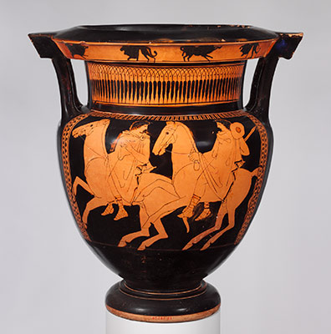

**Topic**

This term or topic revolves around performance, drama and the stage. We will be looking at the Ancient Greeks, performance and art. We will be making masks and devising plays and sketches to express music and stories across the curriculum.

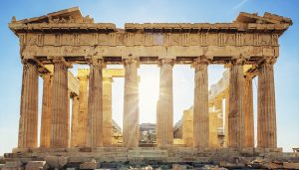

**English**

Children will have daily vocabulary, reading, spelling, handwriting and grammar work. Our focus this half term will be on play scripts and poetry. We will be looking at writing for performance – especially limericks and riddles. In our narrative writing we are going to be looking at building suspense and drama in our writing composition.

**PSHE**

This half term we will look at changes and moving on. We will also have sessions based around our Thrive ethos.

**“All the world’s a stage!”**

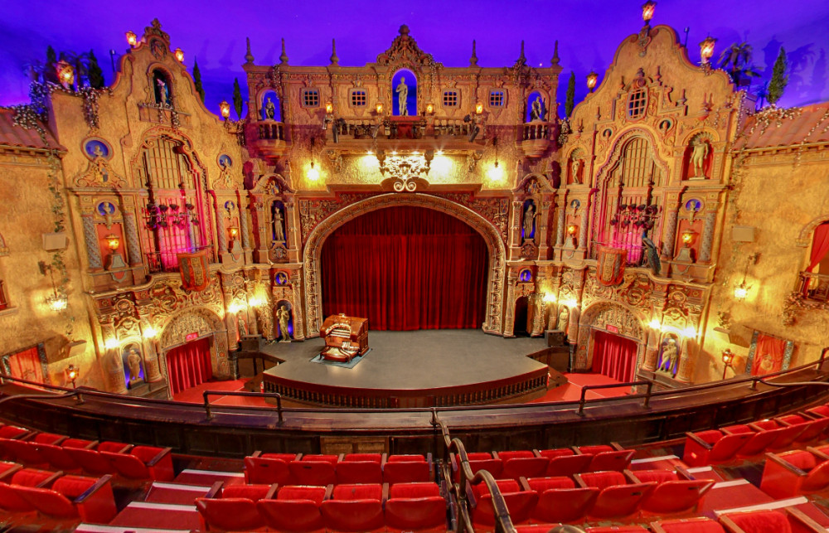

**Languages**

This term we will be looking at Ancient Greek! 

**Science**

This half term we are looking at living things, including Sex and Relationships education and the effect drugs and alcohol has on the body. Please see the letter coming home about these sessions before we begin them.

**Physical Education**

We are looking at the Physical aspect of PE this term, concentrating on balance and agility.

**Computing**

We are going to be looking at word processing skills and skills for life in everyday settings. We will focus on shortcuts, keyboard skills and basic formatting.



**Maths**

Children will explore reasoning, problem solving and mental arithmetic daily. We will continue to work on developing accurate and speedy recall of times tables and division facts, and will now include word problems with this. Our main focus this term will be area and perimeter, converting measures, symmetry and translations

**RE**

We are looking at worship through stories and hymns. Each week we will look at a new story or hymn and explore the theme within it through drama or performance.