**Design Technology and Art**

We will be looking at new Technology from the Victorian period and the many inventions that revolutionised our world. This will be done in a cross curricular way in our topic lessons. Children in year 5 will be looking at Victorian artists like Lowry and exploring many aspects of Victorian art in mixed media.

**Topic**

This term our focus is the Victorian era. We will look at how industry and factories made Britain great, look at the inventors and technology that changed the world and explore what it was like to be a Victorian. This will include a Victorian school day and looking at how the poor were treated.

**English**

Children will have daily vocabulary, reading, spelling, handwriting and grammar work. Following on from our topic work, our writing will include persuasive adverts and diary entries. Our class novel will continue into next term and will be the novel “Wonder” by R.J Palacio.

**Languages**

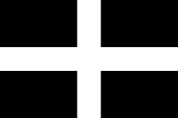

Our new language will be Cornish! We will begin by learning basic Cornish phrases, numbers, colours and greetings.

**Science**

This half term our focus is on electricity and power. We will look at how our use of power has changed from Victorian times to the modern day. We will explore circuits, both building and fixing them. We will look at technology and simple machines and inventions. We will also have a trip to the Geothermal Energy Site at United Downs.

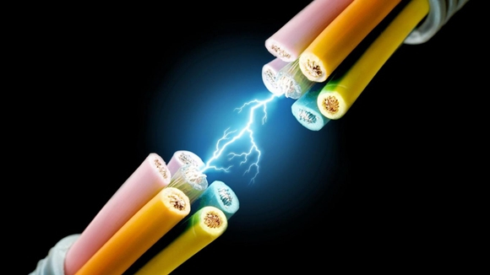

**The Workshop of the World**

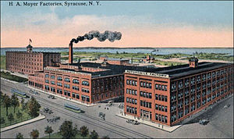

**Physical Education**

This term children in year 6 will be going to Truro College and working with their sport leaders to develop their skills. All children will have yoga, running and skipping sessions.We will also have a look at Lawn Bowls and Boule.

**Maths**

Children will explore reasoning, problem solving and mental arithmetic daily. We will continue to work on developing accurate and speedy recall of times tables and division facts, and will now include word problems with this. Our main focus this term will be fractions, decimals and percentages. We will also begin to look at measuring space and angles.

**Computing**

In computing this term we will be recapping safety, exploring the internet and communication technology including the binary system. We will link this to our Victorians topic by looking at telecommunications from the Victorian era to the present day.

**PSHE**

We will continue to look at friendships and managing our own wellbeing. We will explore negative thinking and what we can do to help manage this. We will also look at how our actions affect others. We will look at inspirational people and why they inspire us.

**RE**

We will be looking at why people believe in God and the impact this has on their lives and the lives of those around them.