**Meet the teacher** 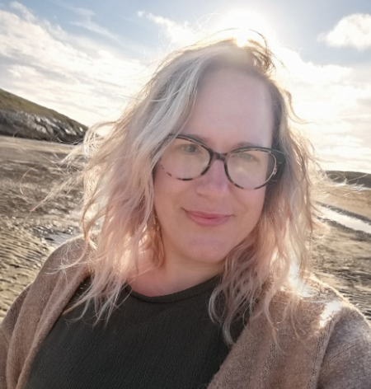

Hi, my name is Mrs Murley and I am going to be your teacher in Wheal Friendly.

I am really looking forward to getting to know you and your grownups and share lots of learning together throughout the year. You are going to be starting an exciting journey I school an I very happy to be joining you all at Blackwater school.

All about me:

I was born in Truro and grew up in Cornwall where I love living! I enjoy spending my time at the beach or my allotment with my family and dog. I have been married for 11 years and have 2 children, a boy and a girl, who are 9 and 6, so I fully understand how it feels to have your child start school and I will be here to support you and your child. I have been teaching for 16 years and have taught in lots of lovely schools all over Cornwall.

My favourite;

Food: Chocolate

Colour: Green, closely followed by yellow!

Film: Anything Disney

Book: Oi, Frog!

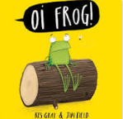   



I hope that you all have a wonderful summer break and I am really looking forward to starting our journey together in September.

*Let’s hope the sun shines!*