List 14 to be tested on 15th January | List 15 be tested on 22nd January | List 16 to be tested on 29th January | List 17 to be tested 5th February
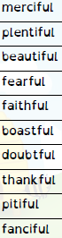 | 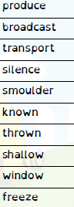 | 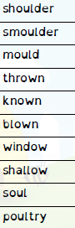 | 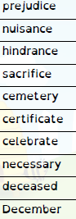
List 18 to be tested 12th February |  |  | Please help your child learn these spellings using the look, cover, write check method each week ready for a test planned on the dates shown. If we have a school trip or visit, the test will go ahead at the earliest date possible after the planned test date.  If you have given consent your child will be able to go online to the Spelling Shed to help them learn and consolidate these spellings.  Many thanks.
